FINALIST
OHE Innovation
Policy Prize 2022

A fairer balance hunting of healthcare innovation and its reward for the common good
Mata Charokopou
Senior Director – Head of Global Payer Strategy & Health Economics
UCB
Dr. Lancelot Henry de Frahan
Post-Doctoral Researcher
University of Chicago
Dr. James Zackheim, PhD
Vice President & Head of Corporate Strategy
UCB
[INSERT OHE DISCLAIMER]

1. INTRODUCTION
The patent system incentivizes innovation by providing temporary market power to innovators so that they can reap a (larger) share of the social surplus of their invention. The pharmaceutical industry is organized around such a system.
The policy arrangement comes at a cost: pricing above marginal cost reduces consumer welfare and generates a temporary deadweight loss on the newly created markets. Since Nordhaus (1969, 1972), there is a well-developed theoretical literature analyzing this tradeoff and deriving formulas for the optimal patent duration. Pharma - in theory - sets the price by trading off the marginal benefits of a price increase with the marginal cost.
We are looking for a policy that would affect the trade-off - at the margin - that Pharma faces when setting its price. The marginal benefit to Pharma of a price increase is, of course, that each drug is sold at a higher price which increases revenue. But there is a marginal cost: lower demand for the drug as the price increases. It is well-known that the ability to set the price without competitors (i.e. market power) theoretically leads the patent-holder to solve this trade-off in a way that results in a price higher than the marginal cost of production, sometimes even above the true value of the product (if someone could estimate it properly) and thus a loss in allocative efficiency.
In this paper, we suggest the use of an additional policy instrument to reduce the distortion from supra-competitive prices in any given time period and more flexibly use the patent system in order to incentivize innovation. Specifically, our proposal is based on a combination of ad-valorem subsidies and a “$\tilde{q}$ -tax”. The $\tilde{q}$-tax imposes tax liability p$\tilde{q}$ on the producer where p is the price set by the monopolist and $\tilde{q}$ is a parameter set by the government. The “$\tilde{q}$-tax” incentivizes lower prices of drugs and brings the market closer to the competitive outcome. The $\tilde{q}$-tax adds an additional element to the aforementioned trade-off faced by Pharma at the margin: a higher tax burden they increase the price. We show in the paper that this leads to better ``allocative efficiency" (that is a more socially beneficial amount of the drug being sold conditioning on it having been already developed and invented).
We are, to our knowledge, the first to propose the use of such a tax. It incentivizes the monopolist to set a lower price and higher quantity, leading to a smaller deadweight loss in each period. It is assessed that the lower price level better reflects a product’s true value and considering competitive market dynamics that potentially impact the holistic value of the product. We assess that the incentivized lower price levels are closer to a fair price, defined as affordable prices that warrant no negative market reaction (and hence access restrictions) and that reflect value created to the society, as perceived by the society, that incentivize innovation, and lean towards allocative efficiency in order to maximize total welfare with given resources.
The $\tilde{q}$-tax decreases producer profit. The latter can however by compensated lump-sum (or, in our model, via ad-valorem subsidies τ) using the proceeds from the $\tilde{q}$-tax. In a given time period, at the margin, introducing the revenue-neutral (from the government’s point of view) version of the policy leads to a first-order gain in consumer surplus but no first-order decrease in profits. As a result, it is always optimal to introduce at least a small amount of the policy. For a larger policy change however, the revenue-neutral combination of $\tilde{q}$ -tax and subsidies would decrease firms’ profit. If the objective is to maintain incentives for innovation constant, the loss in profit could be re-couped via an extension of patent duration.
The system, combining a $\tilde{q}$-tax to incentivize lower prices with increased patent duration, allows for a smoother time path for drug prices. This is illustrated in figure 1.

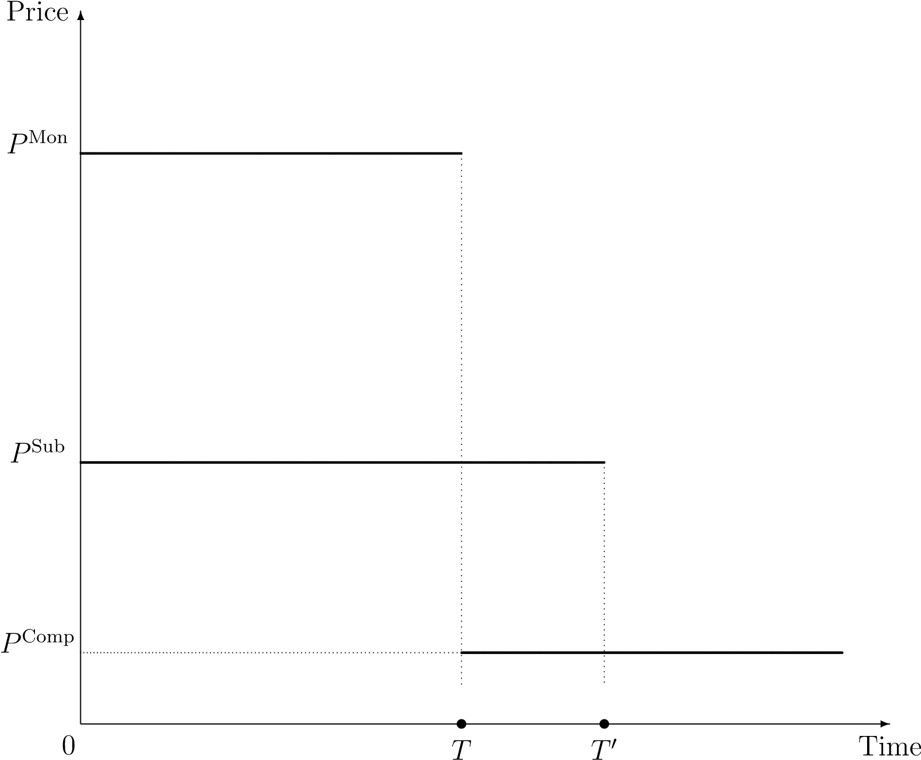

Figure 1: Price of pharmaceutical drugs over time: current versus proposed system.
Instead of consumers facing the full monopoly price (P^{Mon}) for T years before it drops to its competitive level (P^{Comp}), the policy would induce innovators to charge price P^{Sub} < P^{Mon} for a duration of T ‘ > T years. As a result, the distortion from monopoly pricing is lower at any point in time under patent protection but spread over a longer duration. It is known since at least Ramsey (1927) that the welfare cost of price distortions (from taxes or market power) is lower when spread over a larger number of markets rather than being concentrated on a small base. This logic is at play in our model: because the deadweight loss from temporary monopoly power in any time is quadratic, the first dollars shaved of the price have a relatively large effect on consumer welfare. As a result, it is optimal to spread a smaller distortion over a longer duration. Next, we take into account the effect of the policy mix on innovation and characterize the mix of patent duration and $\tilde{q}$ that maximizes the discounted sum of profit and consumer surplus over all (potential) markets.
The optimal patent duration, T, is such that the ratio of the (discounted) deadweight loss on each market to the (discounted) consumer surplus is equal to the elasticity of the supply of innovation. As a result, optimal duration is increasing in the elasticity of supply of innovation and decreasing in the ratio of deadweight loss (from temporary monopoly power) to consumer surplus on each market.
The optimal level of $\tilde{q}$ is such that the elasticity of (after tax) profit of the innovator with respect to $\tilde{q}$ is equal to the elasticity of the deadweight loss on each market (with respect to $\tilde{q}$). As a result, the optimal level of subsidies is decreasing in the elasticity of producer profit and increasing in the elasticity of the deadweight loss.
Aside from the elasticity of supply of innovation, all elasticities depend on the shape of the demand curve on the markets for drugs. As a result, the optimal policy can be calibrated based “only” on knowledge of the shape of demand curves on markets for drugs, and of the elasticity of supply of innovation.
In our formulas, we also account for a “selection term” in order to accommodate heterogeneous demand curves across drugs: if the drugs that are kept from being invented by increases in $\tilde{q}$ are disproportionately those with lower consumer surplus relative to those that are screened-in by an increase in patent duration, the optimal $\tilde{q}$ is larger.
A practical difficulty of the $\tilde{q}$-tax is that it can be harmful if set too high. We argue that the context of pharmaceutical drugs is one in which the government has much external information about the size of the potential market. For example, the number of individuals diagnosed with a given disease or impairment contains much information about the size of the market for a cure. In addition, we note that the allocation achieved by a revenue-neutral combination of the $\tilde{q}$-tax and an ad-valorem subsidy can also be achieved by a revenue neutral combination of an ad-valorem tax and a per-unit subsidy. So, in contexts where the focus is on efficiency only, not raising government revenue, a government could choose either set of instruments depending on whether per-unit subsidies or the $\tilde{q}$-tax are easier to calibrate on that particular market.
The paper is organized as follows. In section 2, we quickly describe the proposed policy. In section 3, we present the model, introduce the $\tilde{q}$ tax and derive its effect - as a function of features of the demand curve - on the equilibrium price, quantity, producer profit, consumer surplus, and deadweight loss on the market in each period. In section 4, we introduce dynamic considerations deriving from the effect of producer profit on innovation. We characterize the optimal policy mix between the $\tilde{q}$ -tax (compensated by ad-valorem subsidies) and patent duration.

2. PROPOSED POLICY
We propose the following policy combination:
- A “$\tilde{q}$-tax”: the government sets some quantity $\tilde{q}$. The drug producer then pays tax liability p$\tilde{q}$ where p is the price set by the producer. Notice that this tax raises some revenue R ≡ p$\tilde{q}$.
- An ad-valorem subsidy: the government subsidizes drug sales at rate τ. The subsidy rate τ is fixed and taken as given by firms but is calibrated by the government so as to spend, on average, the amount (= R) that is raised by the $\tilde{q}$-tax. Under such calibration, the subsidy rate is:
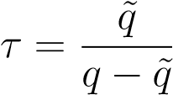 (1)
where q is the quantity sold by the producer.
- Patent duration: similar to current policy, the patent is granted for some duration of T’ years.
In section 3, we explore the effects of τ and $\tilde{q}$ on the price paid by consumers, the consumer surplus, and producer profit. In section 4 we discuss how to calibrate all three parameters {q,τ,T’} so as to maximize the discounted sum of profit and consumer surplus over all (potential) markets.

3. Effects of the $\tilde{q}$-tax on the price, consumer surplus, and producer profit
We assume that the marginal cost of manufacturing the drug is zero. Under that assumption, the ad-valorem subsidy enters as a multiplier in front of the profit function and does not affect pricing. Under the proposed policy, the per-period profit of the drug producer is:
Π($\tilde{q}$,τ) ≡ (1 + τ) $\max_{q}${P (q)(q − $\tilde{q}$)} (2)
where P (q) is inverse demand (i.e. the price necessary to sell q units). Formally, we can show that the effect of an increase in $\tilde{q}$ on quantity sold is:

$\frac{dq}{d\tilde{q}}=\frac{P_{q}}{2P_{q}+P_{qq}\left(q-\tilde{q}\right)}≥0$ (3)
Therefore, the effect on price equals $P_{q}\frac{dq}{d\tilde{q}}≤0$. In other words, the introduction of a $\tilde{q}$-tax increases quantity sold and leads to a decrease in price.
Let us now turn to the effect of a $\tilde{q}$-tax (whose revenue is re-distributed via the appropriate rate τ) on profit (Π), consumer surplus (CS) and deadweight loss (DWL). The effect on producer profit is:
$\frac{dΠ\left(\tilde{q},τ\right)}{d\tilde{q}}=-P\left(q\right)+ \frac{dR}{d\tilde{q}}=\tilde{q}P_{q}\frac{dq}{d\tilde{q}}≤0$ (4)
The effect on the per-period consumer surplus is:
$$\frac{dCS}{d\tilde{q}}=-D\left(p^{*}\right)\frac{dp^{*}}{d\tilde{q}}$$
$=-q^{*}P_{q}\frac{dq^{*}}{d\tilde{q}}≥0$ (5)
where q∗ is the equilibrium quantity set by the monopolist. Finally, collecting the effects on Π and CS, we can express the effect on the deadweight loss:
$$\frac{d DWL}{d\tilde{q}}=-\left[\frac{d CS}{d\tilde{q}}+ \frac{d Π}{d\tilde{q}}\right]$$
$$=-P_{q}\left[\tilde{q}-q^{*}\right]\frac{dq^{*}}{d\tilde{q}}$$
$=-p^{*}\frac{dq^{*}}{d\tilde{q}}≤0$ (6)
From (6), we see that the $\tilde{q}$-tax decreases the DWL and hence increases allocative efficiency on the market in each period. Intuitively, the source of inefficiency on a monopolized market is the internalization, by the producer, of the (negative) effect of selling an additional unit on the price of infra-marginal units. This effect is proportional to quantity q. The tax diminishes this effect so that it becomes proportional to q-$\tilde{q}$ instead, thereby incentivizing the producer to behave closer to the benchmark of a competitive market.
An alternative, and useful, way of understanding why the $\tilde{q}$-tax moves the equilibrium closer to the perfectly competitive outcome is to consider the following thought experiment. Assume the exogenous entrance into the market of a quantity $\hat{q}$ of the good. This corresponds to an exogenous increase in market competition in a Cournot model. Maintaining the definition of q as the total quantity sold on the market, the profit function of the monopolist (assuming $\tilde{q}$= 0) becomes $P(q)\left(q-\hat{q}\right)$. We can directly see that an increase in $\hat{q}$ has the same effect on the monopolist's behavior as an increase in the $\tilde{q}$-tax. In other words, the introduction of a $\tilde{q}$-tax generates the same incentives for the producer as an exogenous increase in competition.

Notice from (4) that, at $\tilde{q}=0$, $\frac{dΠ}{d\tilde{q}}=0$. In other words, the first little bit of a $\tilde{q}$-tax (compensated by τ) does not reduce producer profit. As can be seen from (5) and (6), it does have a first-order effect on consumer surplus and deadweight loss though. Therefore, introducing an infinitesimal compensated $\tilde{q}$-tax leads to a Pareto improvement. However, for any larger increase in $\tilde{q}$, producer profit is lowered.
These two latter facts have the following implications. First, it is always efficient to introduce a little bit of the policy (i.e. the compensated increase in $\tilde{q}$). Second, from a dynamic perspective, the fact that any larger increase in $\tilde{q}$ reduces profit means that the optimal level of $\tilde{q}$ rests on a trade-off between innovation and static allocative efficiency. In the next section, we derive formulas characterizing the policy combination that optimally trades-off these two dimensions under some notion of social welfare.

4. incentives to innovate
As discussed so far, the $\tilde{q}$-tax allows the government to raise revenue on a monopolized market while also increasing consumer surplus and partly restoring efficiency at the cost of a decrease in the monopolist's profit. In the context of monopoly power deriving from a patent, profit is desirable from a dynamic perspective because it incentivizes innovation. As a result, we consider the effect of a $\tilde{q}$-tax whose revenue is rebated lump-sum to the monopolist. This way, the efficiency gains from the $\tilde{q}$-tax can be achieved at a lower cost from the monopolist's perspective and hence at a lower cost in terms of lost innovation. Yet, despite the compensating subsidies, for a combination of a $\tilde{q}$-tax and subsidy τ that keeps government revenue constant, the producer’s profit is lowered. Patent duration is an additional policy lever that can be used by the government to affect incentives to innovate. We build on this idea in the next sections and characterize the optimal combination of a compensated $\tilde{q}$-tax and patent duration taking into account their combined effect on both allocative efficiency and amount of innovation.
Under patent policy, the drug producer receives the profit defined above for T periods.
We define a discount factor r and 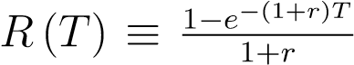. Firms compare R&D costs (C_{F} ) to the net of tax discounted sum of profit (over T years) and decide to develop all new drugs for which C_{F} ≤ R(T)Π($\tilde{q}$,τ). Assume that C_{F} follows distribution F_{c} (C_{F} ) across potential drugs. The distribution of costs F_{c} (.) defines the supply of new drugs as a function of profit received by producers on each new market created. Let us write this function S (π).
We define total social welfare as the (discounted) sum of producer profit and consumer surplus over all markets:
where 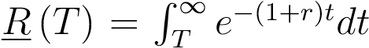 and CS∗ is the consumer surplus when the drug is priced at marginal cost.
We are interested in the optimal revenue-neutral policy combination of a $\tilde{q}$-tax (accompanied by subsidy $τ=\frac{\tilde{q}}{q-\tilde{q}}$), and patent duration that maximizes social welfare. The formulas describing the optimal policy mix are:
(7)
and
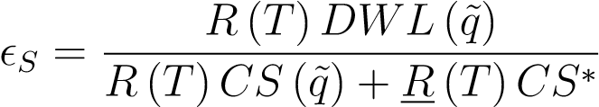. (8)
where the notation |_{G=0} emphasizes that, for any change in $\tilde{q}$, there is a corresponding change in τ such that the policy is revenue neutral. Equation (7) captures the optimal choice of $\tilde{q}$ given some patent duration T. It is composed of three terms.
The first term, $ϵ_{S}≡\frac{S^{'}\left(π\right)}{S\left(π\right)}π$ is the elasticity of the supply of innovation with respect to discounted producer profit. The second term, 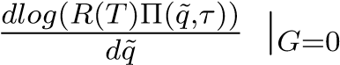 is the semi-elasticity of producer profit with respect to $\tilde{q}$. The third term, on the right-hand side, is a ratio. The numerator is the change in deadweight loss resulting from an increase in $\tilde{q}$. The denominator is the total consumer surplus generated by each innovation over an infinite period of time (which is CS ($\tilde{q}$) for the first T periods and CS∗ afterwards). We obtain the following comparative statics. The optimal choice of $\tilde{q}$ is decreasing in the elasticity of the supply of innovation ($ϵ_{S}$), in the semi-elasticity of producer profit to $\tilde{q}$, and in the total size of consumer surplus generated by each new market. It is increasing in the magnitude of the effect of $\tilde{q}$ on the deadweight loss on each market. Equation (8) captures the optimal choice of patent duration T. The numerator on the right-hand side is the deadweight loss on each market over the duration of the patent. The denominator is the total size of consumer surplus on the market over all future periods. The optimal patent duration is increasing in the elasticity of the supply of innovation and decreasing in the ratio of deadweight loss to total consumer surplus. We can re-arrange (8) and plug in (7) to obtain:
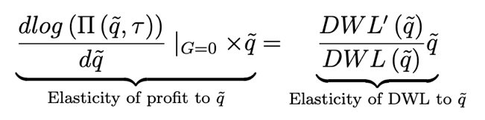 (9)
When patent duration is optimally set (i.e. when (8) is satisfied), the corresponding optimal level of the $\tilde{q}$-tax is such that the elasticity of private profit to a compensated increase in $\tilde{q}$ is equal to the elasticity of the deadweight loss with respect to $\tilde{q}$. The implication is that there is a relatively simple formula that can be used to calibrate $\tilde{q}$ and it does not depend on the value of T at the optimum. Once the optimal $\tilde{q}$ is determined, one can find the optimal T from (8).
In practice, different patented drugs will lead to markets of different sizes, with different demand elasticities and possibly different pass-through rates (of the $\tilde{q}$-tax to consumer prices). Heterogeneity across markets matters because compensated increases in the $\tilde{q}$-tax may screen-out a different set of markets than the set that would be screened-in by an increase in patent duration. The optimal balance between $\tilde{q}$ and patent duration also depends on which group generates a higher social surplus. This selection effect can be important and provides a rationale for basing the incentives for innovation on a patent system to begin with.
In appendix A, we derive the formulas for the optimal $\tilde{q}$-tax and patent duration in an extended model where the demand curve for each drug differs. The resulting equations are similar to (7) and (9) except that there is an additional covariance term. The covariance is between the percentage change in number of drugs invented in response to a marginal increase in $\tilde{q}$ and the total consumer surplus generated by each drug. A higher covariance leads to a higher optimal $\tilde{q}$.
Until now, we have assumed that the government was able to set τ on each market so that it exactly rebated the revenue from the $\tilde{q}$-tax to the monopolist on each market. Of course, the value of τ has to be set ex-ante by the government so that it is taken as given by the producer (otherwise it directly affects pricing incentives). This requires that the government have a considerable amount of ex-ante information about the demand curve on each market which seems unrealistic. In appendix B, we discuss what happens under the more realistic assumption that the government sets a unique τ such that the budget is balanced only on average over all markets. Under the latter assumption, the optimal policy is still characterized by equations (8), (7), and (9). But the effect of the policy on each producer depends on the demand curve they face. Compared to the benchmark in which the government exactly compensates each producer, the policy will tend to select for demand curves such that producers pick a large equilibrium quantity.

5. Calibration of Parameters $\left\{\tilde{q},τ,T\right\}$ through application of the Policy
In section 4, we have presented a framework to think about the optimal calibration of the three policy levers $\left\{\tilde{q},τ,T\right\}$ at the regulator’s disposal under our proposal. The goal of this section is to show that all information needed for such calibrations can be obtained provided one has access to the right data. Admittedly, some of the parameters whose knowledge is required for calibration are a bit challenging to measure in practice. However, this is a feature of the problem at hand rather than a characteristic of our policy proposal. Parameters such as the societal value of innovation or the responsiveness of innovation to policy or the evolution of the actual net price levels of products are fundamentally difficult to estimate. Despite these difficulties, we argue that our framework (and attempts to calibrate it) are a useful guide for improving policy. In addition, one could envision our proposed policy being run dynamically and iteratively by a government entity accumulating knowledge as they experiment and set the value of the policy parameters.
Formulas (7), (8), and (9) describe the optimal policy combination. Broadly, these formulas depend on two sets of key parameters: the elasticity of innovation to profit ($ϵ_{s}$) on one hand, and various characteristics of the demand curve on each market on the other hand.
The body of evidence on the elasticity of innovation and R&D investments to profit is small. Budish, Roin and Williams (2016) review the existing empirical evidence. Most of the few earlier studies cited in their survey found an extremely small response of innovation and R&D investment to changes in patent laws. There are reasons to think that the evidence in these studies is somewhat flawed as they consider changes in domestic patent policy while, arguably, foreign patent laws affect incentives to innovate as well (and sometimes to a much greater extent in the case of small countries). There are two exceptions that leverage a different source of identifying variation and coincidentally find larger numbers. Abrams (2009) finds that a one-year extension of patent duration generates a 66 percent increase in patent filings. Author acknowledges that this number is likely an upper-bound and that the large effect may be partly or entirely driven by when patents were filed over time (as opposed to a true increase in patent number). Budish, Roin, and Williams (2015) find – under some assumptions – that a one year increase in patent duration leads to a 7-24 percent increase in R&D investment. Even in our experience of COVID19, a potential TRIP waiver is seen a disincentive to innovation, as recently stated by efpia (European Federation of Pharmaceutical Industries and Associations). The bottom line is that relatively little is known about the magnitude of the response of innovation to profit and patent laws due to the challenges inherent to measuring such a parameter. There exists, however, clever studies that make progress on this issue. Numbers from these studies can be used to guide policy.
There are three characteristics of the demand function that determine the optimal policy mix: the elasticity of producer profit to the compensated $\tilde{q}$-tax $\left({\left.\frac{dlog\left(Π\left(\tilde{q},τ\right)\right)}{dlog\left(\tilde{q}\right)}\right| }_{G=0} \right)$, the elasticity of the deadweight loss to the compensated $\tilde{q}$-tax $\left(\frac{d{DWL}^{'}\left(\tilde{q}\right)}{DWL\left(\tilde{q}\right)}\right)$, and the ratio of deadweight loss to consumer surplus $\left(\frac{R(T)DWL(\tilde{q})}{R\left(T\right)CS\left(\tilde{q}\right)+\underline{R}\left(T\right){CS}^{*}}\right)$. These are all entirely determined by the shape of the demand function. These features can further be classified in two categories: “local properties” of demand and “global properties”. Local properties describe the shape of the demand curve locally, around the current equilibrium. By contrast, global properties describe the entire shape of the demand curve, even at prices and quantities far away from the current equilibrium. For instance, the consumer surplus, and thus the social value of innovation, depends on global properties of demand as it depends on the value of the drugs to infra-marginal, as well as, marginal consumers.
Fortunately, there exists a type of policy variation that allows to identify the local properties of the demand curve needed to calibrate the policy. Assume that the firm is subject to both a $\tilde{q}$-tax and a per-unit subsidy t. Then, we can show that $\frac{dp}{d\tilde{q}}=P_{q}×\frac{dp}{dt}$. In other words, a small per-unit subsidy of size $-P_{q}∆$ has the same effect on the price as a small $\tilde{q}$-tax of size $∆$. An implication is that a small subsidy of size $-P_{q}∆$ also has the same effect on consumer surplus and deadweight loss as a small $\tilde{q}$-tax of size $∆$. The important difference between these policies is that the $\tilde{q}$-tax raises revenue whereas the subsidy is costly to the government. The significance of this result is that if one can measure the effect of per-unit subsidy on the market for drugs on price, consumer surplus and deadweight loss, one essentially has knowledge of the effect of the $\tilde{q}$-tax. This is significant because a $\tilde{q}$-tax has never been implemented while we can certainly find plenty of examples of per-unit subsidies being imposed on drug markets. Data about the effect of these subsidies on price and quantity of drugs sold is therefore very informative for the purpose of calibrating the optimal $\tilde{q}$-tax.
Finally, global properties of the demand curve are more difficult to estimate. Usually, one has to impose some more a priori structure on the demand curve in the model so as to reduce the number of parameters to be estimated. One then uses local properties of the demand function to inform these parameters and use the structure imposed on demand to extrapolate its shape at all prices and quantities. A good practice here would be to check the sensitivity of the calibrated policy parameters to the a priori assumptions imposed on the shape of demand.
A dynamic application starting with a local pilot with a group of countries, probably those that historically have valued innovation more than others in an effort to maintain or increase incentives (e.g. Nordics) and/or the Inflation Reduction Act (IRA) could be a great vehicle to pilot in the US. We start with a “data collection” phase that would allow targeted calibration of the parameters with producers volunteering or piloting through specific disease spectrum (e.g. gene therapies). We, then, propose to move to an “optional phase”, through e.g. the individual alternative minimum tax (AMT), where producer is asked to pay the lesser of the tax considered. Finally, the “mandatory phase” could apply with an e.g. 5-year notice. We would expect an organic expansion at global scale given that allocative efficiency would have a halo effect and incentivized innovation is not meant to be limited to a jurisdiction given universal access goals.

6. Conclusion
We make two main contributions. First, we introduce the $\tilde{q}$-tax. It is a simple instrument that allows a government to raise revenue on a market protected under a patent while also improving allocative efficiency by bringing the equilibrium closer to the competitive outcome. This is particularly useful, because the distortions from both market power and traditional per-unit or ad-valorem taxes are quadratic so that is is typically more costly, from the point of view of efficiency, to tax monopolized (i.e. already distorted) markets. On the contrary, a $\tilde{q}$-tax improves efficiency. It can be construed as a Harberger tax (Weyl and Zhang 2021; Posner and Weyl 2018) applied to production decisions on the intensive margin instead of the extensive margin decision of allocating a discrete asset. In the context of the pharmaceutical industry, we recommend combining the $\tilde{q}$-tax with ad-valorem subsidies $τ$ to producers in order to counterbalance the effect of the $\tilde{q}$-tax on prospective profits of innovators and thus on innovation. The subsidy rate $τ$ can be calibrated so as to exactly redistribute the proceeds of the $\tilde{q}$-tax.
Second, we argue that regulators should consider using the $\tilde{q}$-tax to more flexibly trade-off static losses from patent-protected monopolies and gains from (profit-incentivized) innovations. We apply this reasoning to the pharmaceutical industry. By setting patent duration to T years, the regulator can achieve an outcome where the price is at the monopoly-level for T years then drops to equal the marginal cost thereafter. Instead, using a combination of patent protection, the $\tilde{q}$-tax, and an ad-valorem subsidy re-distributing the gains from the $\tilde{q}$-tax directly to producers, a regulator could grant a fraction of monopoly power for some T’ (possibly > T) years. The additional flexibility of setting the fraction of monopoly power attributed under the patent can lead to welfare gains.
The resulting policy could lead to a higher consumer surplus on infra-marginal markets, or a higher supply of innovation, or a combination of both. An important objective of our proposal is for policy-makers to treat pricing, tax, and patent policies as interdependent. Eventually, all three levers need to be combined in the pursuit of affordable prices (leading to universal access to better healthcare) while maintaining or improving the quantity and quality of innovation generated by the pharmaceutical industry.
A key assumption in our framework is that the price drops down to the competitive level once the patent expires. In practice, it is unclear whether this is always the case. We caution that to achieve its full potential, our policy proposal would ideally be combined with efforts by policy-makers to use competition policy and similar levers in order to maintain the competitiveness of the markets for drugs whose patent has expired.

References
- Abrams D. (2009), ``Did TRIPS Spur Innovation? An Empirical Analysis of Patent Duration and Incentives to Innovate”, University of Pennsylvania Law Review, 157:1613-47.
- Budish E., Roin B.N., and H.Williams (2015), ``Do Firms Underinvest in Long-Term Research? Evidence from Cancer Clinical Trials”, American Economic Review, 105(7):2044-85.
- Budish E., Roin B.N., and H.Williams (2016), ``Patents and Research Investments: Assessing the Empirical Evidence”, American Economic Review: Papers & Proceedings, 106(5):183-187.
- Bulow J.I. and P. Pfleiderer (1983), “A Note on the Effect of Cost Changes on Prices”, Journal of Political Economy, 91(1):182-185.
- Fabinger M. and E. G. Weyl (2012), “Pass-Through and Demand Forms”, Working Paper, December 2012.
- Kremer M. (2000a), “Creating Markets for New Vaccines. Part i: Rationale”, in Innovation Policy and the Economy, A. B. Jaffe, J. Lerner, and S. Stern, eds., (Cambridge, MA: National Bureau of Economic Research), Volume 1, 35-72.
- Kremer M. (2000b), “Creating Markets for New Vaccines. Part ii: Design issues”, in Innovation Policy and the Economy, A. B. Jaffe, J. Lerner and S. Stern, eds., (Cambridge MA: National Bureau of Economic Research), Volume 1, 73-118.
- Nordhaus W.D. (1969). “Invention Growth, and Welfare: A Theoretical Treatment of Technological Change”, The MIT Press: Cambridge, MA.
- Nordhaus W.D, (1972). “The optimum life of a patent: Reply”, American Economic Review, 623:428-431.
- Posner E.A. and E.G. Weyl (2018). Radical Markets: Uprooting Capitalism and Democracy for a Just Society, Princeton: Princeton University Press.
- Ramsey F. (1927). “A Contribution to the Theory of Taxation”, Economic Journal, 37(March):47-61.
- Weitzman M.L. (1974). “Prices vs. Quantities”, Review of Economic Studies, 41(4):477491.
- Weyl E.G. and A.L. Zhang (2021). “Depreciating Licenses”, Conditonally accepted AEJ: Economic Policy (June 2021).
- Weyl E.G. and M. Fabinger (2013), “Pass-Through as an Economic Tool: Principles of Incidence under Imperfect Competition”, Journal of Political Economy, 121(3): 528583.
- Weyl E.G. and J. Tirole (2012), “Market Power Screens Willingness-to-Pay”, The Quarterly Journal of Economics, 127(4):1971-2003.

OHE Innovation
Policy Prize
The OHE Innovation Policy Prize supports our charitable goal of improving the quantity and quality of debate on health economics, and has been designed to be a non-exclusive platform which:
- generates novel ideas and solutions
- facilitates sharing of perspectives across disciplines countries
- encourages more research into the economics of the life sciences sector

The OHE Innovation Policy Prize awards £40,000 for the entry that best fulfils our judging criteria; originality, empirical/theoretical foundations, global feasibility/implementation, potential impact, and clarity. All short-listed entries also have the opportunity to submit a paper to a special issue or section of PharmacoEconomics based on their entry.

The next OHE Innovation Policy Prize will launch in 2024.

Having been at the forefront of economics and policy of health and life sciences innovation for the past 60 years, OHE has a rich history of supporting and promoting original thinking which solves the problems of the day and the future.

This issue is reminiscent of the debate between quotas and pigouvian taxes in the literature on externalities following the seminal contribution of Weitzman 1974.
In practice, the marginal cost is non-zero but negligible relative to R & D cost or average willingness to pay by consumers so this is a useful approximation.
3 We are assuming that after the patent expired, competition drives prices down and they equal marginal cost.
https://efpia.eu/news-events/the-efpia-view/blog-articles/what-would-be-the-impact-of-a-waiver-extension/

