FINALIST
OHE Innovation
Policy Prize 2022

A Framework for the Fair Pricing of Medicines
Dr Mike Paulden
Associate Professor
University of Alberta, Canada
[INSERT OHE DISCLAIMER]

ACKNOWLEDGEMENTS
I would like to thank [anonymized] and [anonymized] for providing support and critical feedback throughout the development of this framework. This manuscript builds upon a conceptual framework that I developed as chair of a working group that informed the Canadian Patented Medicine Prices Review Board (PMPRB)’s modernization of its price review process guidelines. This conceptual framework was included in the final report of this working group, available on the Government of Canada’s website [1]. I wish to thank anonymous members of the working group who provided feedback on this conceptual framework. This manuscript also builds upon some earlier work that was included in an appendix to a 2018 report by the Institute of Health Economics (IHE) and funded by the PMPRB [2]. I would like to thank [anonymized] and [anonymized] for co-authoring that report, and the IHE and PMPRB for supporting the research. Finally, I would like to thank the Office of Health Economics (OHE) for supporting the dissemination of this research through their Innovation Policy Prize. While some earlier findings from this work have been publicly disseminated, none of the research in this manuscript has previously been published in a peer-reviewed journal. All errors and omissions remain the responsibility of the author.

1. INTRODUCTION
A growing challenge faced by public health care payers around the world is deciding which medicines to approve for reimbursement, and at what price. As higher-cost medicines put increasing pressure on public health care budgets [3], the need to identify ‘fair’ prices for medicines has never been greater.
Economic evaluations of medicines form an important component of health technology assessment (HTA) processes [4]. These are increasingly used during negotiations over the prices of new medicines between payers and manufacturers [5]. Conventionally, these economic evaluations involve a comparison of a medicine’s incremental cost-effectiveness ratio (ICER) to a cost-effectiveness ‘threshold’ [6].
The past decade has seen numerous advancements in the theoretical and empirical literature regarding how such a ‘threshold’ should be specified [7–10]. At present, there are two conceptually different approaches, termed ‘demand-side’ and ‘supply-side’; a demand-side approach assumes that the ‘threshold’ should reflect a socially legitimate aggregation of individuals’ willingness-to-pay for a marginal improvement in population health, while a supply-side approach assumes that the ‘threshold’ should reflect the health opportunity cost of reimbursing medicines within a budget constrained health care system (i.e. the health loss experienced by other patients) [11,12].
In practice, reimbursement decisions involve a number of considerations that are not taken into account by either approach. If the ‘threshold’ is low, manufacturers may be unable to supply some medicines at a profit; manufacturers may also choose not to invest in developing new medicines. If the ‘threshold’ is high, some manufacturers may make substantial profits, yet the net benefit to patients may be small or even negative. Conventional approaches also do not consider how specifying a ‘threshold’ can result in strategic pricing behaviour by manufacturers.
1.1 PURPOSE
The purpose of this paper is to propose a framework that addresses some important limitations with conventional approaches. The proposed framework incorporates considerations from both supply-side and demand-side approaches, including the health opportunity cost borne by other patients and society’s willingness-to-pay for marginal improvements in population health. The framework considers the costs incurred by manufacturers in developing and supplying new medicines, and the incentive for manufacturers to strategically price up to any ‘threshold’ used by the payer.
The framework is built upon fundamental economic principles, allowing for consideration of the ‘consumer surplus’ and ‘producer surplus’ arising from the reimbursement of medicines, and how different prices impact upon the distribution of total welfare between patients (consumers) and manufacturers (producers). This allows for consideration of a ‘fair’ price for a medicine.
1.2 A ‘FAIR’ PRICE FOR A MEDICINE
The concept of ‘fair’ is inherently normative. When pricing medicines, there are numerous stakeholders with different interests and perspectives on what a ‘fair’ price would be.
We consider a ‘fair’ price to be one that, at a minimum, balances the interests of patients and manufacturers. We also recognize that ‘fairness’ is required in the way the public health care system treats different patients, and how it rewards different manufacturers:
- We consider it ‘fair’ for the payer to assign equal value to equivalent impacts upon the health of patients, regardless of whether those patients benefit from medicines or bear the opportunity cost of their reimbursement.
- We recognize that larger manufacturers may be in the position to negotiate more favourable prices with the payer than smaller manufacturers. Where medicines are priced collectively (Section 4), we consider it ‘fair’ for the payer to offer the same reward for a given improvement in health to all manufacturers, regardless of circumstances.
1.3 OHE INNOVATION POLICY PRIZE
This paper was submitted in response to the 2022 OHE Innovation Policy Prize, which posed the following question:
“How can policymakers design a system to generate fair prices that balances access and innovation throughout the lifecycle of medicines?”.
The language used throughout the paper, including in the definitions below, is aligned with this question.
1.4 DEFINITIONS AND ASSUMPTIONS
Policymakers
For the purposes of our framework, ‘policymakers’ are defined as the ‘payers’ responsible for approving reimbursement and negotiating the prices of medicines within a collectively funded public health care system with a constrained budget. The implications for other policymakers (such as those regulating private insurance markets) are considered in Section 7. 3
Perspective
The perspective adopted by the payer (‘policymaker’) is assumed to be a ‘publicly funded health care payer’ perspective, consistent with the reference case used by numerous HTA agencies internationally [4]. Under this perspective, the objective of the payer is assumed to be to improve population health outcomes. The implications of adopting a societal perspective, or an objective of maximizing equity-weighted population health, are considered in Section 7.
Constrained budget
The public health system budget is assumed to be constrained, such that reimbursing a medicine that imposes incremental costs results in a loss of health for other patients. This is considered further in Section 3.
Reserve prices and reserve ICERs
We assume manufacturers incur costs of production and will not supply at a loss. We further assume that there is a single minimum price at which a medicine’s manufacturer is willing to supply to the public health care system in question, hereafter referred to as the ‘reserve price’.
The medicine’s reserve price implies a corresponding ‘reserve ICER’; that is, the medicine’s ICER when priced at its reserve price, given its incremental effectiveness. Reserve prices and reserve ICERs are assumed to differ across medicines.
Competition
We assume that manufacturers of new medicines are protected from competition by a time-limited patent monopoly. This allows manufacturers to raise prices above those required to cover marginal costs of production. The time-limited nature of patent protection raises important dynamic considerations that are considered in Section 6.
Endogeneity between prices and the payer’s ‘threshold’
Given the protection from competition offered by patents, we assume that manufacturers strategically price according to any ‘threshold’ specified by the payer.
This endogeneity can arise for many reasons, including manufacturers ‘pricing up’ to the ‘threshold’ [13], or manufacturers setting a higher initial price and then negotiating down to the ‘threshold’ (as occurs in Canada) [5,14]. A formal system of ‘value-based pricing’, as has been proposed in the literature, would also explicitly result in pricing at this ‘threshold’ [15].
1.5 STRUCTURE OF THE PAPER
The structure of the paper is as follows:
- We begin by outlining the fundamental economic principles underpinning our framework (Section 2).
- We then construct our basic framework and use it to consider the range of ‘fair’ prices when pricing medicines independently (Section 3) or collectively (Section 4).
- We extend our framework by considering the risks that the manufacturer and payer incur when developing and reimbursing medicines (Section 5).
- We then consider the potential for prices to change over the lifecycle of a medicine, and the need to use dynamic modelling when establishing a ‘fair’ price (Section 6).
- We consider a number of other potential extensions to our basic framework (Section 7).
- Finally, we discuss the implications for the ‘fair’ pricing of medicines (Section 8).

2. ECONOMIC PRINCIPLES
At any given price, the ‘total welfare’ from a good is the sum of:
- The ‘consumer surplus’, which is the benefit obtained by consumers because they are able to purchase the good at a price lower than their ‘willingness-to-pay’.
- The ‘producer surplus’, which is the benefit obtained by producers because they are able to sell the good at a price higher than their ‘willingness-to-accept’.

This provides a useful starting point for considering a ‘fair’ price for a medicine: the price should be high enough for a positive producer surplus, but low enough for a positive consumer surplus.
2.1 STANDARD MODELS
Microeconomics has a number of standard models that describe how consumers and producers behave under different market conditions. Two standard models are of particular relevance:
- In a perfectly competitive market, an equilibrium price arises at which there is positive consumer surplus and positive producer surplus. 2.
- In a monopoly with a single price, the producer reduces output and raises the price so as to maximize producer surplus. Consumer surplus is diminished but remains positive.
Critically, both the consumer surplus and the producer surplus are strictly positive in each of these standard models.¹ It is therefore reasonable to expect both to be positive when reimbursing a medicine within a public health care system.
This provides a useful starting point for considering a ‘fair’ price for a medicine: the price should be high enough to provide a positive producer surplus, but low enough to provide a positive consumer surplus.
2.2 BASIC FRAMEWORKS
Over the following sections we outline a basic framework, grounded in the economic principles considered above. In order to remain accessible, this basic framework makes a number of simplifying assumptions; the implications of relaxing many of these assumptions will be considered in Section 7

3. PRICING MEDICINES INDEPENDENTLY
We will begin constructing our basic framework under the simplifying assumption that medicines are priced independently. Later we will extend our framework to consider medicines collectively.
To consider the consumer and producer surplus arising from reimbursing a medicine within a public health care system, we must first specify demand and supply curves.
3.1 DEMAND CURVE
Given our perspective, a reasonable specification of the payer’s demand curve is based on the net impact on the lifetime health of patients associated with reimbursing the medicine within the publicly funded health care system in question, where health is measured using a commonly accepted unit and discounted to a present value.
The use of equity-weighting and/or an alternative perspective would imply a different specification of the demand curve; we consider the implications of this in Section 7.
Given a constrained budget, the net impact of reimbursing a medicine upon the health of patients is a function of two components:
- The gain in health experienced by patients who receive the medicine; and
- The loss in health experienced by other patients whose health care subsequently receives less funding than it would have done if the medicine were not reimbursed.
Health gain
The gain in health for patients who receive the medicine is routinely estimated as part of economic evaluations conducted by HTA agencies, and will hereafter be denoted as ∆𝐻.
¹ While the standard model of monopoly can be extended to consider perfect price discrimination, in which consumer surplus is zero, the assumptions underpinning this are unlikely to arise in practice given information constraints and the monopsonistic purchasing power of public health care payers.
There is often uncertainty when estimating ∆𝐻, due to limitations in the clinical evidence base; this has implications for the determination of a ‘fair’ price, which we consider in Section 5.
For simplicity, our basic framework will consider medicines with one indication only, and assumes homogeneity within this indication, such that ∆𝐻 remains constant as the quantity of medicine increases; the implications of relaxing these assumptions are considered in Section 7.
Health loss
Since the patients who incur health opportunity costs are typically unidentifiable, the standard approach for estimating the magnitude of the health loss is to divide the incremental cost of the medicine (hereafter denoted as ∆𝐶) by the ‘supply-side threshold’ (typically denoted as 𝑘), which reflects the marginal productivity of spending within the relevant health care system budget. Recent and ongoing empirical work has attempted to estimate 𝑘 for various public health care systems around the world [16].
As a hypothetical example, if 𝑘 is estimated to be £15,000 per QALY, this means that every incremental £15,000 of cost imposed on the health care budget would be expected to result in a health loss of 1 QALY for other patients. Supposing ∆𝐶 is £60,000, this implies an estimated health loss of 4 QALYs (∆𝐶/𝑘); reimbursing this medicine would therefore be expected to improve population health (i.e. provide positive consumer surplus) only if ∆𝐻 exceeds 4 QALYs.
There is uncertainty in estimating the health loss, due to uncertainty in both ∆𝐶 and 𝑘. This is important when determining a ‘fair’ price for the medicine, and will be considered in Section 5.
For simplicity, we assume that medicines have ‘marginal’ net budget impact, and that there is a single budget; the implications of relaxing these assumptions are considered in Section 7.
Plotting the demand curve
Under the simplifying assumptions above, the demand curve for a medicine may be plotted as a perfectly elastic horizontal line, stretching from the vertical axis to the quantity of medicine for which there is clinical need (Figure 1). This horizontal line is plotted at the price at which the health gain from the medicine (∆𝐻) is exactly offset by the health loss (∆𝐶/𝑘), such that the net impact of reimbursing the medicine on population health is zero. That is, the demand curve plots the price at which:
Rearranging equation (1), it follows that the demand curve plots the price at which the ICER of the medicine equals 𝑘:
For the hypothetical medicine in Figure 1, the ICER equals at a price of P1 𝑘 , such that the demand curve is also plotted at this price.
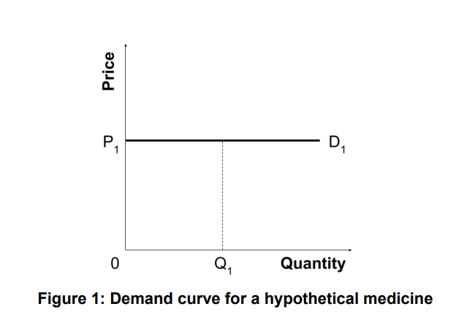
A price below P1 results in positive consumer surplus (e.g. P2 in Figure 2), since the health gain exceeds the health loss, such that net population health outcomes are improved. The consumer surplus is equal to the area of the green region in Figure 2.
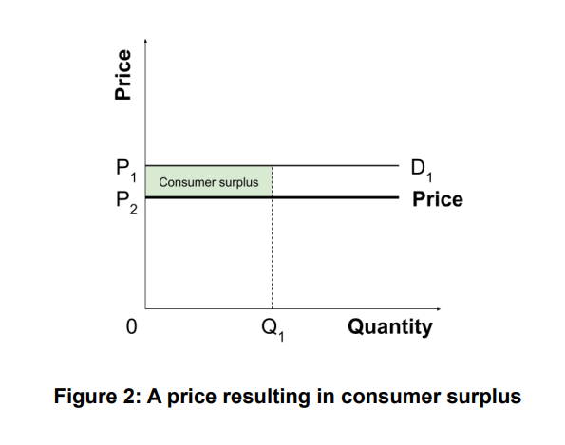
At a price of P1 , the consumer surplus is zero (there is no area between the price and the demand curve, which exactly overlap). A price above P1 results in negative consumer surplus, since the health loss exceeds the health gain. As noted earlier, a zero or negative consumer surplus is not an outcome that arises in relevant standard models in economics, and does not accord with our definition of a ‘fair’ price.
How demand curves vary between medicines
All else equal, the more effective a medicine is at improving health outcomes (∆𝐻), the greater the price at which the ICER equals , and hence the higher the demand curve (e.g. D2 𝑘 in Figure 3); conversely, the less effective a medicine is at improving health outcomes, the lower the demand curve (e.g. D3 in Figure 4).
How demand curves vary across different countries
Theoretical and empirical research suggests that 𝑘 is higher in countries with greater health spending per capita [9,16]. All else equal, a higher value of 𝑘 results in a higher demand curve. For any given medicine, a richer country would be expected to have a higher demand curve (e.g. D2 in Figure 3) than a poorer country (e.g. D3 in Figure 4).
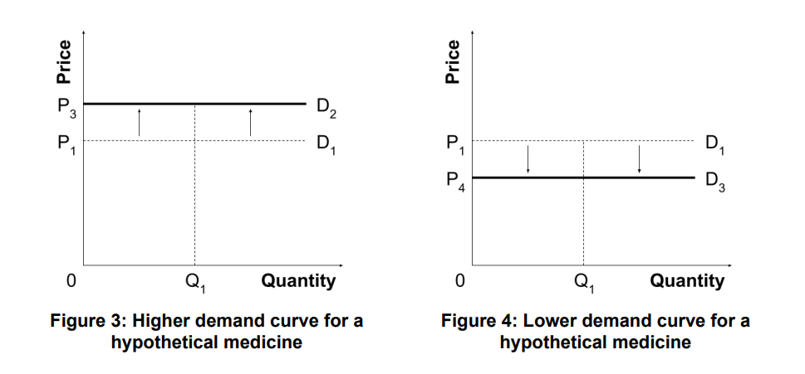
3.2 SUPPLY CURVE
The supply curve plots the lowest price that a manufacturer would be willing to accept when supplying any given quantity of medicine to the public health care system in question.
Plotting the supply curve is challenging. It is a function of many factors, including (but not limited to) marginal costs of production, and the potential implications for ‘reference pricing’ in other jurisdictions (a manufacturer might be unwilling to accept a price, even if it covers marginal costs, if doing so results in a lower price in other jurisdictions).
Furthermore, manufacturers have incentives to keep information on the above factors confidential, and make efforts to do so in practice [17–19]. Payers therefore generally have little 10 information from which to estimate the supply curve for any given medicine. For the purposes of this framework, the supply curve will therefore be treated as unobservable to the payer.
3.2 TOTAL WELFARE
The demand and supply curves may be used to consider the ‘total welfare’ (or ‘economic surplus’) that arises from reimbursement of a medicine at any given price and quantity, and the distribution of this between patients (consumer surplus) and manufacturers (producer surplus).
In Figure 5, the consumer surplus is illustrated by the green area below the demand curve and above the price (P5 ), while the producer surplus is illustrated by the blue area above the supply curve and below the price (P5 ).

3. ECONOMIC PRINCIPLES
To consider a medicine’s consumer and producer surplus requires demand and supply curves
DEMAND
Under simplifying assumptions, the demand curve is a perfectly elastic horizontal line plotted at the price at which the ICER equals 𝑘 (Figure 1).

A price below P1 results in positive consumer surplus (e.g. P2 in Figure 2), since the health gain exceeds the health loss. A price equal to or higher than P1 does not result in consumer surplus, so is not ‘fair’.

Supply curve
The supply curve is a function of many factors, including marginal costs of production and the potential implications for ‘reference pricing’ in other jurisdictions. Manufacturers have incentives to keep information on these factors confidential. For the purposes of this framework, the supply curve is treated as unobservable to the payer.
TOTAL WELFARE
In general, there is a range of possible ‘fair’ prices at which consumer and producer surplus, and the sum of these (‘total welfare’), are positive (e.g. P5 in Figure 5).
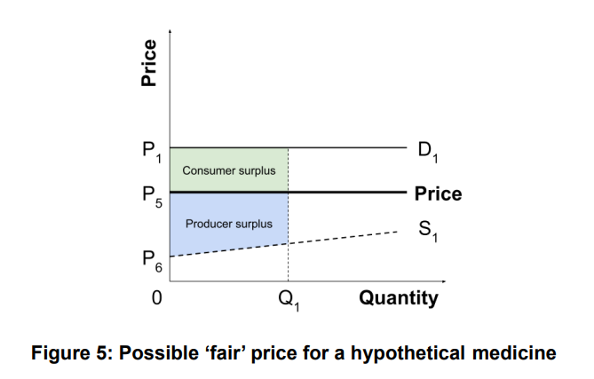
In general, where the supply curve lies below the demand curve, there is a range of possible ‘fair’ prices at which consumer and producer surplus are both positive (e.g. P5 in Figure 5).
The upper bound of this range is a price corresponding to the demand curve (P1 in Figure 5), such that the ICER equals 𝑘. At this price, the entirety of the economic surplus is allocated to the producer and consumer surplus is zero. As argued earlier, this is not a ‘fair’ share of the economic surplus; at a minimum, a ‘fair’ price must be below this upper bound, such that consumer surplus is strictly positive.
The lower bound of this range is determined by the location of the supply curve. Since the supply curve is unobservable to the payer, this lower bound is unknown in practice.
Appendix A1 considers medicines that cannot be supplied at a ‘fair’ price (that results in a positive surplus for both consumers and producers), and a potential solution to this problem.

4. PRICING MEDICINES COLLECTIVELY
In practice, the inability of the payer to observe supply curves places an important limitation on considering medicines independently, and provides a rationale for extending our framework to consider a ‘fair’ common price for a unit of health that applies to all medicines collectively.²
A collective approach has some notable advantages:
- It provides manufacturers with a clear signal as to the payment they will receive for any additional units of health gain provided by medicines they develop. This reduces uncertainty as to the manufacturer’s return on investment (Section 5). Manufacturers made clear the desirability of such “clear bright lines” during recent consultations
² We use the term ‘common price’, instead of ‘threshold’, to avoid confusion with existing terminology around the ‘demand-side threshold’ and ‘supply-side threshold’.
conducted by Canada’s Patented Medicine Prices Review Board (PMPRB).[1]
- It rewards efficient research and development (R&D). Since manufacturers can ‘price up’ to the common price regardless of their reservation price, they can receive disproportionately large returns if their production costs are low and/or their medicines are highly effective. Conversely, manufacturers who develop costly and ineffective medicines will receive lower returns, disincentivizing inefficient R&D.
In determining a ‘fair’ common price, we must consider the total consumer and producer surplus arising from all medicines reimbursed at each potential common price.
4.1 aDDITIONAL ASSUMPTIONS
Our collective approach makes the following assumptions, further to those outlined in Section 1.
Common price
A single common price for a unit of health, λ, is publicly specified by the payer. Given the assumption of endogeneity between prices and λ, reimbursed medicines with a reserve ICER below λ are supplied and priced such that the ICER equals λ. Medicines with a reserve ICER greater than λ are not supplied.
Medicines are independent
Medicines are considered independent, such that (not) reimbursing a specific medicine has no impact on the reserve ICERs for other medicines.
4.2 hypothetical example
Given the confidential nature of manufacturers’ reserve prices in practice, we will illustrate our approach using a simple hypothetical example (Table 1).
There are four medicines, each of which will be supplied only if the common price specified by the payer (in £ per QALY) equals or exceeds the manufacturer’s reserve ICER. If a medicine is supplied, it will be reimbursed at the common price and will provide the health gain reported in Table 1. Any costs of reimbursement fall on a public health care budget and diminish the health of other patients; we assume is £15,000 per QALY, in line with UK empirical estimates [21].³
To consider the total welfare (sum of consumer and producer surplus) at any given common price, both must be valued in a common metric. For this we use a ‘demand side’ threshold (𝑣). Recent work by Woods et al. [22] used two different values of 𝑣: £60,000 per QALY, based on the value of a statistical life year (SLY) used by the UK Government [23]; and £30,000 per QALY, a value closer aligned to recent literature [11,12,24]. We adopt the same approach.

³ Note that the generalizable findings from this example (Section 4.6) hold regardless of the value of k.
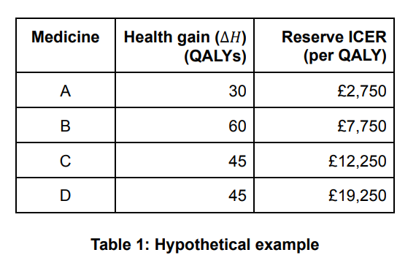
4.3 CONSUMER SURPLUS
We begin by calculating consumer surplus (population health impact) at different common prices. To illustrate the key insights of this approach, we will consider three common prices within the range of reserve ICERs (£5,000, £10,000, and £15,000 per QALY, where the last equals 𝑘), as well as a common price below this range (£0 per QALY) and one above this range (£20,000 per QALY). We will consider each in turn, from smallest to largest.
Common price of £0 per QALY
At this very low common price, no medicines are reimbursed because every reserve ICER lies above the common price. No health gain is provided, but there is also no health loss, so the net impact on population health is zero. This is illustrated by the green dot at the origin of Figure 8.
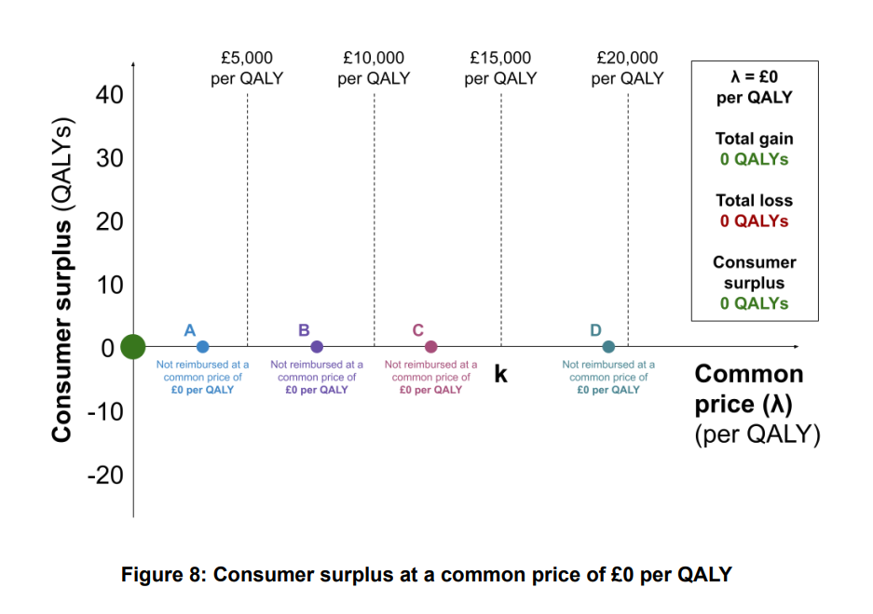
Common price of £5,000 per QALY
At a common price of £5,000 per QALY, medicine A is supplied because the common price exceeds its reserve ICER.
The health gain for patients receiving A is 30 QALYs. Although its reserve ICER is £2,750 per QALY, it is priced up to the common price of £5,000 per QALY (illustrated by the blue dashed arrow in Figure 9). With a health gain of 30 QALYs, and an ICER of £5,000 per QALY, it follows that the incremental cost of A is £150,000. Since 𝑘 is £15,000 per QALY, the health loss from reimbursing A is 10 QALYs. Reimbursing A at this common price therefore improves population health by 20 QALYs, comprising a 30 QALY gain and a 10 QALY loss.
The remaining medicines are not supplied, providing no health gain but also no health loss. The consumer surplus is therefore 20 QALYs, illustrated by the green dot in Figure 9.
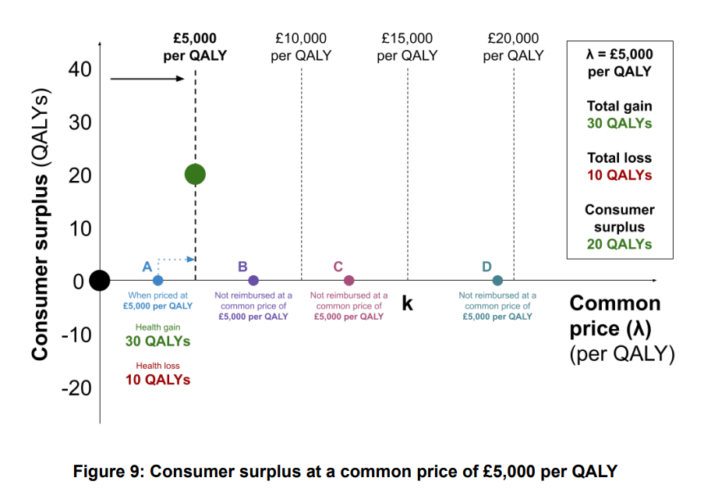
Common price of £10,000 per QALY
Increasing the common price to £10,000 per QALY has two countervailing effects.
Medicine B is now supplied, and is priced up to £10,000 per QALY. With a health gain of 60 QALYs, and an ICER of £10,000 per QALY, the incremental cost is £600,000. The health loss is therefore 40 QALYs, such that reimbursing B improves population health by 20 QALYs.
However, by increasing the common price, medicine A is now priced up to £10,000 per QALY. Its incremental cost is now £300,000, so the health loss to other patients is now 20 QALYs (compared to 10 QALYs at a common price of £5,000 per QALY). Reimbursing A at this higher common price therefore improves population health by only 10 QALYs (rather than 20 QALYs).
Since medicines C and D are not supplied, the total health gain is 90 QALYs and the total health loss is 60 QALYs. The consumer surplus is 30 QALYs, illustrated by the green dot in Figure 10.
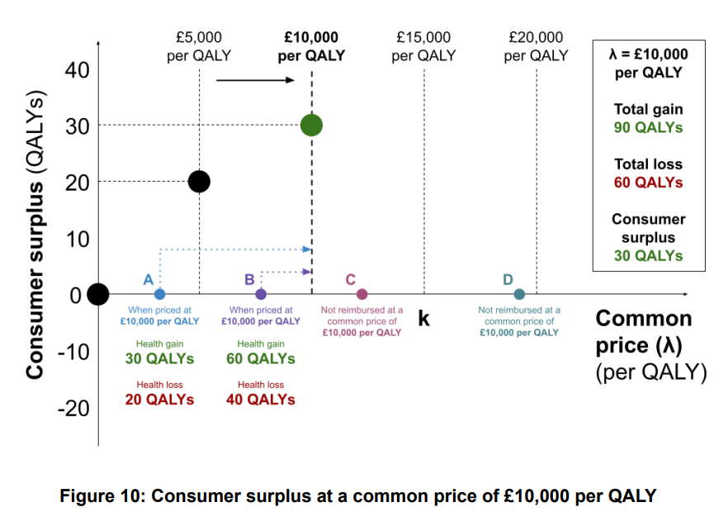
Common price of £15,000 per QALY
At a common price of £15,000 per QALY, medicine C is now supplied and priced up to £15,000 per QALY. With a health gain of 45 QALYs, the incremental cost is £675,000 and the health loss is also 45 QALYs. Reimbursing C has no net impact on population health, since the health gain equals the health loss.
Increasing the common price also results in medicines A and B being priced up to £15,000 per QALY. The incremental cost of A and B is now £450,000 and £900,000, resulting in a health loss of 30 QALYs and 60 QALYs respectively, in each case equal to the health gain. Reimbursing A and B at this higher common price therefore nullifies their net impact on population health.
Medicine D is still not supplied, so the total health gain is 135 QALYs and total health loss is also 135 QALYs, resulting in no consumer surplus, as illustrated by the green dot in Figure 11.
Note that our finding of zero consumer surplus at a common price equal to 𝑘 is generalizable beyond this example: any medicine priced at 𝑘 provides no net impact on population health, since the health gains are exactly offset by the health losses. This has critical implications for determining a ‘fair’ common price for medicines in practice.
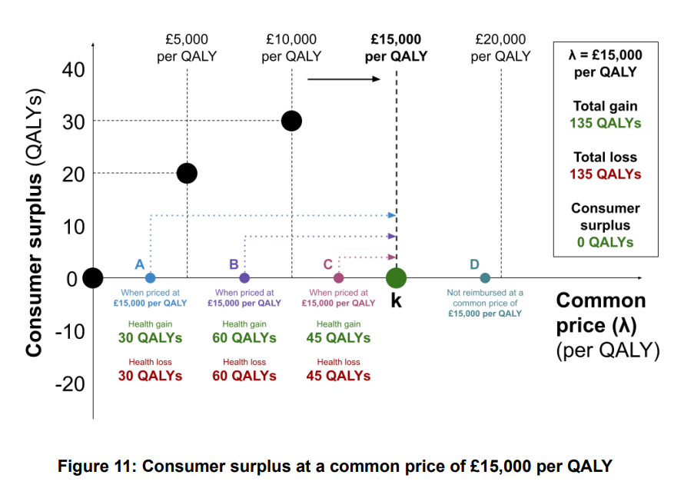
Common price of £20,000 per QALY
At a common price of £20,000 per QALY, above the entire range of reserve ICERs, all four medicines are supplied and priced up to £20,000 per QALY; since this exceeds 𝑘, all four medicines displace more QALYs through their reimbursement than they provide to patients.
Given their associated health gains (Table 1), the incremental costs are now £600,000 for medicine A, £1,200,000 for B, and £900,000 for each of C and D; the resulting health loss is now 40 QALYs for A, 80 QALYs for B, and 60 QALYs for each of C and D. The total health gain is 180 QALYs and the total health loss is 240 QALYs, resulting in a net loss in population health (i.e. a negative consumer surplus) of 60 QALYs; this is illustrated by the green dot in Figure 12.
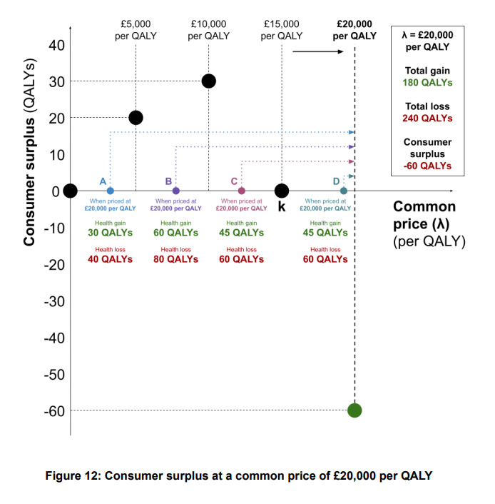
Maximizing consumer surplus
Although the greatest consumer surplus in the analyses above arose at a common price of £10,000 per QALY, these five common prices are not exhaustive, and in fact the maximum consumer surplus arises at another common price: £7,750 per QALY. This corresponds to the reserve ICER of medicine B, where the consumer surplus is 43.5 QALYs.
It is no coincidence that consumer surplus is maximized at a common price corresponding to a reserve ICER for a medicine somewhere below 𝑘: this is a general finding. The trend observed in the consumer surplus (initially increasing with the common price, before reaching a maximum and declining to zero at a common price of 𝑘) is also a general finding. These general findings are discussed in Section 4.6.
4.3 Producer surplus
The assumption that manufacturers are unwilling to supply at a loss has the following implications for the producer surplus:
- If the common price is lower than a medicine’s reserve ICER, the manufacturer will not supply and the producer surplus will be zero.
- If the common price equals the medicine’s reserve ICER, the medicine will be supplied but the producer surplus will remain zero.
- If the common price exceeds the reserve ICER, the medicine will be supplied and will be priced up to the common price. Producer surplus will be positive, and can be calculated by subtracting the incremental cost of the medicine (over all patients) at the reserve ICER from the (higher) incremental cost at the common price.
For example, if the incremental cost is £100,000 when priced at the reserve ICER (where producer surplus is zero), but increases to £300,000 when priced up to a higher common price, the producer surplus is £200,000.
Common price of £0 per QALY
At this low common price, no medicines are supplied because each reserve ICER lies above the common price. Producer surplus is zero, illustrated by the blue dot at the origin of Figure 13.
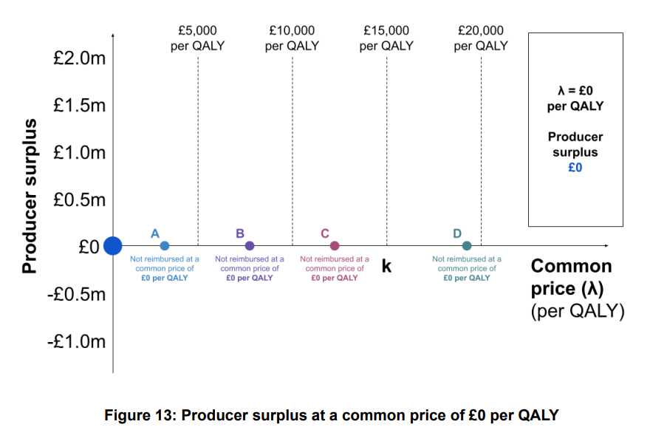
Common price of £5,000 per QALY
At a common price of £5,000 per QALY, medicine A is now supplied.
At its reserve ICER (£2,750 per QALY), medicine A would have an incremental cost of £82,500. Instead, it is priced up to £5,000 per QALY, so the incremental cost is £150,000. The increase in its incremental cost (£67,500) represents the producer surplus accruing to the manufacturer at this common price.
Since no other medicines are supplied, the total producer surplus is £67,500, illustrated by the blue dot in Figure 14.
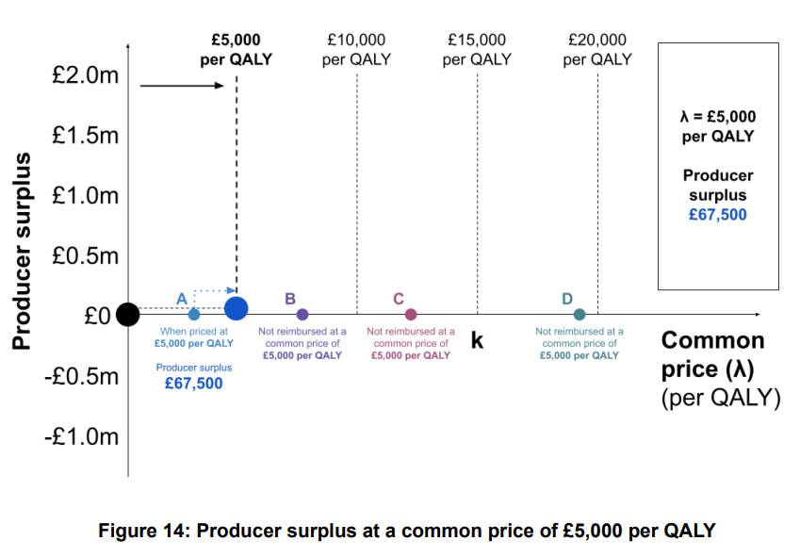
Common price of £10,000 per QALY
At a common price of £10,000 per QALY, medicine B is now supplied. Both A and B are priced up to £10,000 per QALY.
At their reserve ICERs, the incremental costs of medicines A and B are £82,500 and £465,000, respectively. At this common price, their incremental costs are £300,000 and £600,000, resulting in a producer surplus of £217,500 and £135,000, respectively.
No other medicines are supplied, so the total producer surplus is £352,500, illustrated by the blue dot in Figure 15.
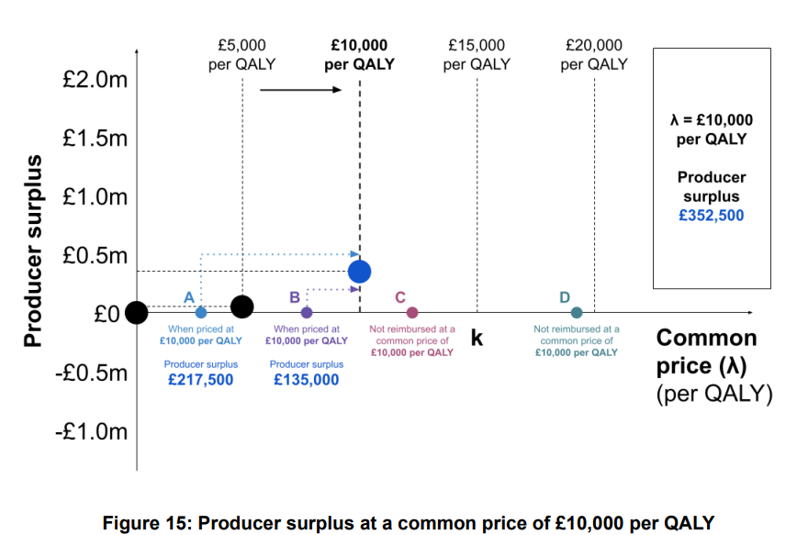
Common price of £15,000 per QALY
At a common price of £15,000 per QALY, medicine C is now supplied. Medicines A, B, and C are all priced up to £15,000 per QALY.
At their reserve ICERs, the incremental costs of medicines A, B, and C are £82,500, £465,000, and £551,250, respectively. At this common price, their incremental costs are £450,000, £900,000, and £675,000, resulting in a producer surplus of £367,500, £435,000, and £123,750, respectively.
Since medicine D is not reimbursed, the total producer surplus is £926,250, illustrated by the blue dot in Figure 16.
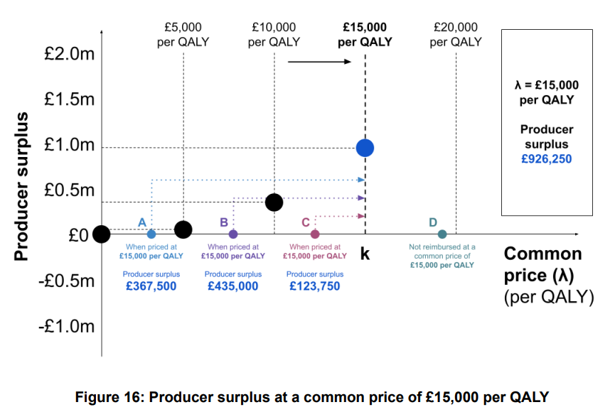
Common price of £20,000 per QALY
At this common price, above the entire range of reserve ICERs, all four medicines are now supplied and priced up to £20,000 per QALY.
At their reserve ICERs, the incremental costs of medicines A, B, C, and D are £82,500, £465,000, £551,250, and £866,250, respectively. At this common price, their incremental costs are £600,000, £1,200,000, and £900,000 for both C and D, resulting in a producer surplus of £517,500, £735,000, £348,750, and £33,750, respectively.
The total producer surplus is £1,635,000, illustrated by the blue dot in Figure 17.
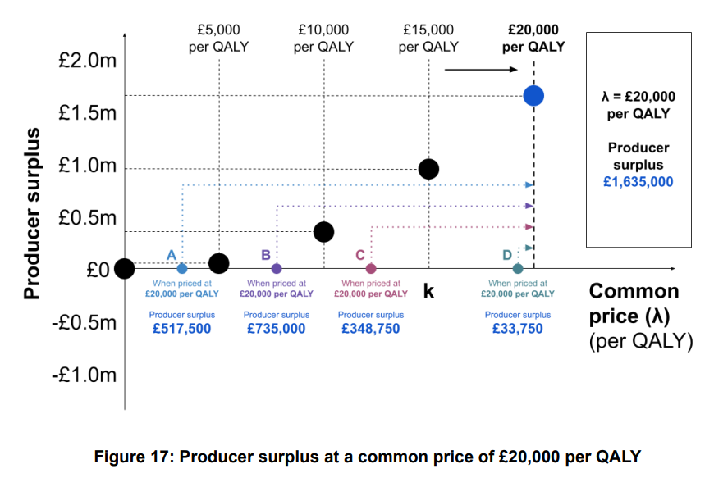
4.5 TOTAL WELFARE
The total consumer surplus (Section 4.3) can be converted into monetary terms using the demand side threshold (𝑣). The total welfare at each common price can then be calculated as the sum of the monetary value of the consumer surplus and the producer surplus (Section 4.4).
Table 2 summarises the consumer surplus, monetary value of the consumer surplus, producer surplus, and total welfare, for the five common prices considered above, for each of 𝑣 = £30,000 per QALY and 𝑣 = £60,000 per QALY.
In our example, for each of 𝑣 = £30,000 per QALY and 𝑣 = £60,000 per QALY, total welfare is maximized at a common price of £7,750 per QALY, coinciding with the reserve ICER for medicine B; this is summarized in Table 2 and highlighted in bold. This is a general finding, discussed further in Section 4.6: under the reasonable assumption that 𝑣 > 𝑘, total welfare is always maximized at a common price below 𝑘 coinciding with the reserve ICER of a medicine.
Note that if 𝑣 is only slightly greater than 𝑘, then the welfare maximizing common price will generally coincide with the highest reserve ICER below 𝑘. In our example, if 𝑣 = £16,000 per QALY, then total welfare would be maximized at a common price of £12,250 per QALY.
While the assumption 𝑣 > 𝑘 is supported by empirical evidence, and 𝑣 ≤ 𝑘 is implausible (given the costs associated with administering both taxation and the public health care system, and the unwillingness of individuals to pay more in taxes to generate a population QALY than the value they assign to it) [2], for the sake of completeness Appendix A2 considers the implications of assuming 𝑣 ≤ 𝑘.
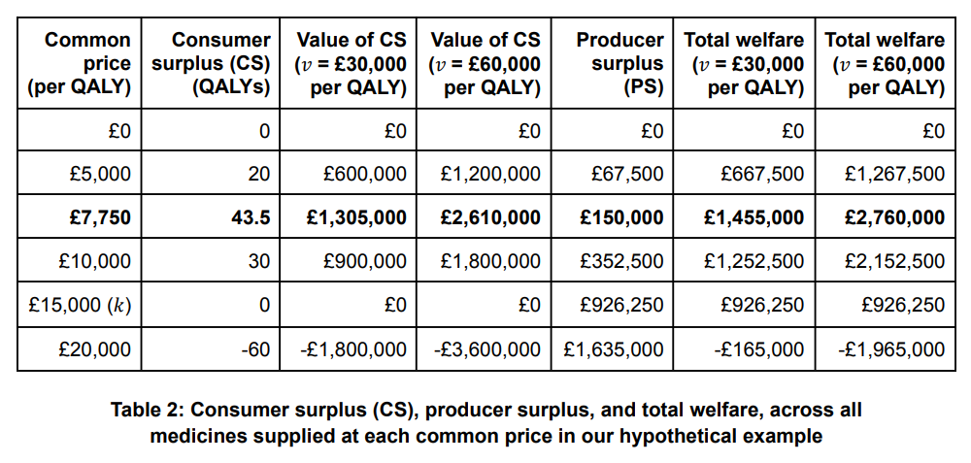
4.6 GENERALIZABLE FINDINGS
Some of the findings of our example are generalizable. These are summarized below and in Figure 18.
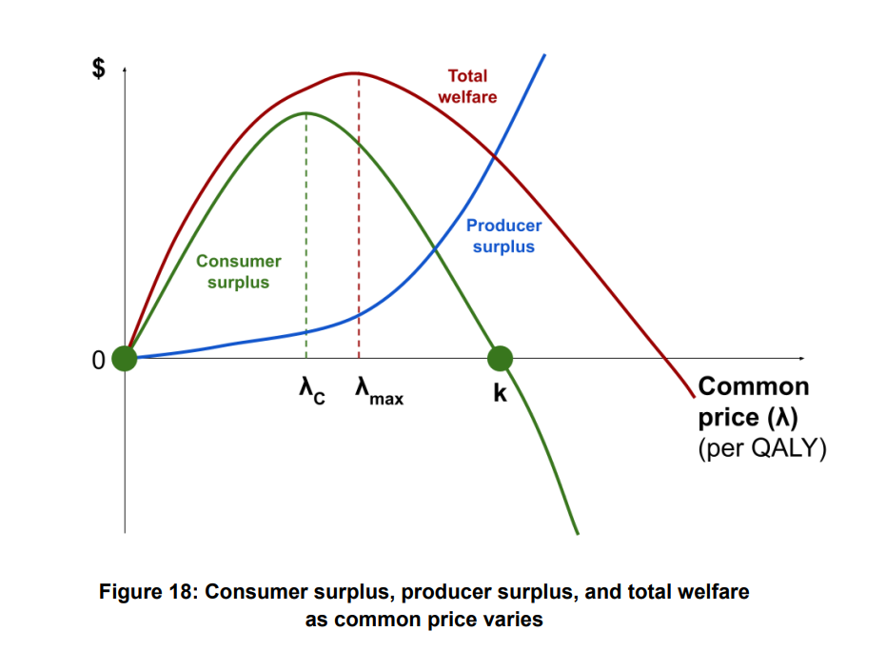
(Note that this figure is plotted under the assumption that the lower bound of the distribution of reserve ICERs is zero.⁴)
Consumer surplus
- Consumer surplus is zero at any common price below the lowest reserve ICER of any medicine. This is because no medicines are supplied, so there is no health gain nor health loss, and so no impact on population health.
- Consumer surplus is positive for common prices above the lowest reserve ICER but below 𝑘. Within this range, a marginal increase in the common price may give rise to two countervailing effects:
  - An increase in consumer surplus due to one or more new medicines being
⁴ If the lowest reserve ICER is above zero, the consumer and producer surplus will be zero for all common prices below that reserve ICER (such that the curves will be flat along the horizontal axis until that point). Alternatively, if the lowest reserve ICER is negative (i.e. there are medicines that dominate their comparator at their reserve price), these will be supplied (and provide a positive consumer and producer surplus) even at a common price of £0 per QALY, such that the curves both intersect the vertical axis above the origin.
supplied, since the common price now equals the respective reserve ICERs. Since these new medicines are priced below 𝑘, their reimbursement improves population health outcomes.
  - A decrease in consumer surplus due to medicines already supplied being priced up to the new common price, diminishing population health outcomes.
At low common prices, where few medicines are supplied, the first effect generally outweighs the second, so a marginal increase in the common price improves consumer surplus (such that the green curve in Figure 18 slopes upwards).
As the common price increases (along with the number of medicines supplied), the relative magnitude of the second effect grows, eventually equalling that of the first. At this common price (denoted as λ ), the consumer surplus is maximized and the green 𝐶 curve in Figure 18 is at its peak). This point always corresponds to the reserve ICER of a medicine.⁵
At common prices above λ but below , marginal increases in the common price result 𝐶 𝑘 in a declining (but still positive) consumer surplus, with the second effect outweighing the first (causing the green curve in Figure 18 to slope downwards).
- At a common price of 𝑘, the consumer surplus returns to zero. This is a critical finding, and arises because any health gains from medicines are exactly offset by the health losses that result from their reimbursement. The green curve in Figure 18 intersects the horizontal axis at this point.
- Above a common price of 𝑘, consumer surplus is negative, and becomes more negative as the common price is increased. This is because all medicines are priced sufficiently highly that their health gains are outweighed by the health losses resulting from their reimbursement, and because any new medicines supplied as a result of increasing the common price are also priced such that they diminish population health outcomes.
Producer surplus
- Producer surplus is zero at any common price below the lowest reserve ICER of any medicine. This is because no medicines are supplied. 2.
- For common prices above the lowest reserve ICER of any medicine, producer surplus unambiguously increases as the common price increases. This is due to two complementary effects:
  - An increase in producer surplus due to one or more new medicines being supplied, since the common price now exceeds the respective reserve ICERs.
⁵ This is because marginal increases in the common price above a medicine’s reserve ICER result in price increases for all medicines reimbursed at that common price; this will unambiguously diminish consumer surplus, unless the marginal increase in the common price is sufficient to result in another medicine being supplied (in which case the common price now corresponds to the reserve ICER of another medicine).
  - An increase in producer surplus due to higher pricing for medicines already supplied, which are now priced up to the new common price.
Total welfare
- Where 𝑣 > 𝑘, total welfare is maximized at a common price at or above λ but below , 𝐶 𝑘 coinciding with the reserve ICER for a medicine. This is plotted as λ in Figure 18. 𝑚𝑎𝑥
- If 𝑣 is only slightly greater than 𝑘, then the welfare maximizing common price coincides with the highest reserve ICER below 𝑘. If 𝑣 is considerably greater than 𝑘, then the welfare maximizing common price coincides with a reserve ICER further below 𝑘.
4.7 ESTABLISHING A ‘FAIR’ COMMON PRICE
As in earlier sections, a ‘fair’ price requires that consumer and producer surplus are both positive. When pricing medicines collectively, the total consumer and producer surplus are both positive at all common prices greater than the lowest reserve ICER of any medicine but below 𝑘.
Nevertheless, an important finding of our framework is that consumer and producer surplus both increase up to a common price of λ_{C}, so there is mutual interest in setting the common price at 𝐶 least as high as λ_{C}. The most relevant range for establishing a ‘fair’ common price is therefore 𝐶 between λ_{C} (where consumer surplus is maximized) and 𝑘 (where consumer surplus is zero).
At any ‘fair’ common price, there will generally be some medicines with low reserve ICERs for which the manufacturer receives substantial profits, and others with higher reserve ICERs for which most of the economic surplus for that medicine is allocated to patients. This is inevitable when setting a ‘fair’ common price for all medicines collectively.
There will also generally be medicines with reserve ICERs above the common price but below k. This raises a number of issues, and is considered further in Appendix A2.

5. return on investment
In previous sections, we defined a ‘fair’ price as one that allocates, at a minimum, a positive share of the total welfare from a medicine’s reimbursement to both consumers and producers.
This principle is consistent with standard models of a market operating under either perfect or imperfect competition. Both consumer and producer surplus are positive in competitive markets, and both remain positive under a standard model of a monopoly.
Yet refinements to this definition might be appropriate. In this section we consider the ‘return on investment’ for both the manufacturer and payer from developing and reimbursing medicines.
5.1 RETURN FOR THE MANUFACTURER
A limitation with the supply curve, and hence producer surplus, is that it only considers costs that increase with the quantity supplied. It does not consider fixed costs, including R&D costs.
Manufacturers incur substantial costs and risks when developing medicines [25], driven by the high costs of regulation for demonstrating effectiveness and manufacturing quality. In addition, they incur the costs of medicines that fail during clinical trials [26]. Investing capital in developing medicines has an opportunity cost, since it could generate positive returns elsewhere [27,28].
A medicine might therefore be supplied at a price that exceeds its marginal costs of production, providing a positive producer surplus, yet have a negative economic profit (producer surplus minus fixed costs).
Our definition of a ‘fair’ price can be refined to address this. Provided the price still results in positive consumer surplus (and a reasonable rate of return for the payer, as considered below), the manufacturer should be allocated a sufficient share of the total welfare to cover fixed costs (including R&D), and enough additional surplus to reward the risk taken in developing the medicine.
In other words, a ‘fair’ price is one at which the producer surplus is not merely positive, but sufficiently positive to provide the manufacturer with a reasonable rate of return on its investment.
5.2 RETURN FOR THE PAYER
The payer also takes risks when reimbursing medicines. Both the health gains and health losses are uncertain. As a result, there can be substantial uncertainty as to the net impact of reimbursing a medicine upon population health.
Reimbursing a medicine should therefore be considered an investment by the payer. Since the broad purpose of a public health care system is to improve the health of the public, the return on this investment should be considered in terms of population health (instead of monetary terms), using the payer’s economic model to estimate the health gains and losses in each time period, discounted to a present value. Probabilistic analysis provides a means to explicitly consider the payer’s risk. It is rational for the payer to seek a return that is proportionate to this risk.
The demand curve, and hence consumer surplus, only considers the payer’s willingness to pay for a marginal unit of medicine, and not the fixed costs that apply regardless of the quantity of medicine reimbursed. Fixed costs include those associated with conducting HTA, making decisions, and investing in the physical and human infrastructure necessary to provide the medicine to patients.
We can refine our definition of a ‘fair’ price to reflect this. Provided the price still results in a reasonable rate of return for the manufacturer (see above), the payer should be allocated enough economic surplus to cover its fixed costs, and enough additional surplus to reward the risk taken in reimbursing the medicine.
In other words, a ‘fair’ price is one at which the consumer surplus is not merely positive, but sufficiently positive to provide the payer with a reasonable rate of return on its investment.
5.3 Equalizing risk-adjusted rates of return
A fundamental principle of financial economics is that a risky investment requires a positive expected rate of return, with a greater risk requiring a greater expected rate of return.
A potential approach to specifying a single ‘fair’ price, within the range considered above, is to equalize the risk-adjusted rates of return for both the manufacturer and payer. This would result in a greater nominal return for the party that incurs the greater risk. For example, if the manufacturer incurs a greater risk in developing the medicine than the payer incurs in reimbursing the medicine, then a greater proportion of the economic surplus would be allocated to the manufacturer.
An advantage of this approach is that it would reward manufacturers who come to market with higher quality evidence, since this would reduce the risks faced by the payer.
A significant challenge for this approach is that the manufacturer’s expected rate of return is typically unknown to the payer. Even if it were disclosed, there would likely be disagreement as to how the risks faced by each party are calculated. Nevertheless, defining the principles needed to characterise a ‘fair’ price is a necessary first step to developing the methods by which it could, in future, be calculated.

6. Pricing over a medicine’s lifecycle
Our framework has so far considered the boundaries of a single ‘fair’ price for a medicine. In practice, a complicating factor is that a medicine is unlikely to have just one price over its lifecycle. For example, the price of a medicine may be expected to fall after patent expiry, when it is subject to generic competition.
This ‘dynamic’ pricing has implications for the consumer and producer surplus arising from a medicine’s reimbursement over the course of its lifecycle. All else equal, a reduction in the price of a medicine following patent expiry would increase the consumer surplus, and reduce the producer surplus, in later years.
It follows that a ‘fair’ price (or ‘fair’ set of prices, if prices change over time) should, as far as practicable, be established over the entire lifecycle of the medicine.
6.1 EXTENDING THE BASIC FRAMEWORK
Our basic framework can be extended to consider this. The principles considered earlier remain: the price (or set of prices) for the medicine should be such that the economic surplus arising from its reimbursement across its lifecycle is allocated fairly between consumers and producers, resulting in a reasonable rate of return for each party.
Changes in a medicine’s prices over its lifecycle can be considered through dynamic modelling using multiple cohorts [29]. Expected changes in medicines’ prices would be explicitly modelled for future cohorts, allowing for estimation of the consumer and producer surplus in each period, and also the rate of return for each party. Uncertainty in future pricing would be incorporated through probabilistic analysis.
6.2 FACTORS TO CONSIDER IN DYNAMIC MODELLING
To calculate a ‘fair’ price (or ‘fair’ set of prices) over a medicine’s lifecycle, a dynamic model would need to take into account the following:
- Expected changes in the price of the medicine over time.
- Expected changes in the price of any comparators. (The patent on a comparator may expire before that of the medicine, increasing the incremental cost of the medicine over the medium term).
- The potential for ‘evergreening’, which reduces the length of time that the payer benefits from a lower price following patent expiry [30]. (The price of a medicine may even increase following the original expiry date of the primary patent [31,32]).
- Expected changes in the future market share of the medicine.
- Time preference, which reduces the present value of any gains in population health arising from a price reduction following patent expiry.
- The uncertainty in the considerations above. (Paying a higher price for a medicine today, on the expectation that the price might fall in future, effectively transfers risk onto the payer. The payer’s expected rate of return from their investment would need to increase to reflect this additional risk (Section 5).
6.3 Establishing a ‘fair’ price using dynamic modelling
The same principles established in our basic framework continue to apply. A ‘fair’ price (or ‘fair’ set of prices) must be high enough to result in a reasonable rate of return for the producer, but low enough to result in a reasonable rate of return for the payer, over the medicine’s lifecycle, when discounted to present values.
If the medicine’s ICER is greater than or equal to 𝑘 when calculated using a dynamic model, this means that the medicine is not expected to improve population health outcomes over its lifecycle, even when taking into account the off-patent period, and hence would not be ‘fair’.
Unlike static models, dynamic models allow the payer to consider the possibility of delaying reimbursement until the price of the medicine falls. In a model with dynamic pricing, the ICER for the medicine will generally change over time as new cohorts enter the model. If a ‘fair’ price cannot be found at launch (because the manufacturer will not supply at a price that provides for a reasonable rate of return for the payer, perhaps because of ‘reference pricing’ considerations in other jurisdictions) then the payer may wish to delay reimbursement of the medicine until the price falls, rather than decline to reimburse outright.

7. Extensions to the basic framework
There are numerous possible extensions to the basic framework outlined in earlier sections. The following are not exhaustive; future research has the potential to provide many more.
7.1 MULTIPLE INDICATIONS AND HETEROGENEITY
The shape and location of a medicine’s demand curve depends upon the health gain (∆𝐻), its incremental cost (∆𝐶), the supply-side threshold (𝑘), and the quantity of medicine for which there is clinical need (Section 3). Where a medicine has multiple indications, one or more of these factors might differ across each indication, resulting in a step function (Figure 19).
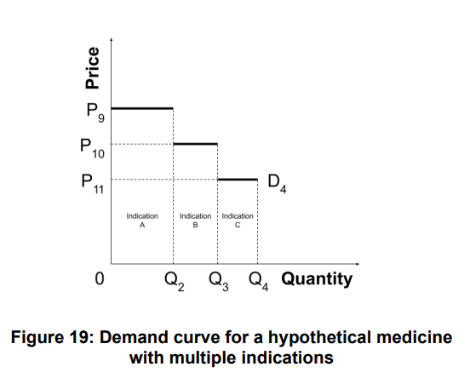
Figure 19 can be used to consider the consumer surplus associated with different approaches to pricing across indications. For example, a single price of P₁₀ across all indications would result in positive consumer surplus from indication A, zero consumer surplus from indication B, but negative consumer surplus from indication C; ensuring that all indications provide a strictly positive consumer surplus requires a price below P₁₁. Alternatively, if separate prices can apply for each indication, then ‘fair’ pricing requires a price below P₉ for indication A, below P10 for indication B, and below P₁₁ for indication C.
Furthermore, where there is heterogeneity in the patient population, the factors above might differ across patients within an indication. Observable heterogeneity can be addressed by allocating patients into subgroups, and the implications for the demand curve are similar to those that arise with multiple indications (resulting in a step function across subgroups).
7.2 NON-MARGINAL NET BUDGET IMPACT
The use of 𝑘 to estimate the health opportunity cost is appropriate only if the net budget impact of the medicine is marginal [33]. Where it is non-marginal (e.g. recent treatments for hepatitis C), the concave health production function may result in a disproportionately large health loss [10].
In such cases, the demand curve will curve down as the quantity increases (Figure 20). A price of 𝑘 will therefore result in negative consumer surplus. A price slightly below 𝑘 (that results in a positive consumer surplus if the net budget impact is marginal) might also result in negative consumer surplus.
The upper limit of the range of ‘fair’ prices is therefore further below 𝑘 than in the basic framework.
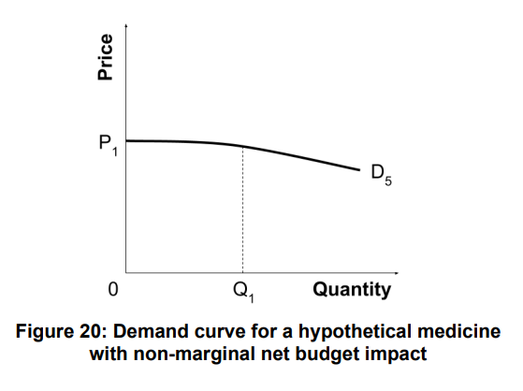
7.3 BUDGETARY SILOS
If the budget for the public health care system has been allocated to separate budgetary ‘silos’, a given incremental cost will generally result in a different health loss depending on the specific silo upon which it falls. In other words, each silo has its own 𝑘.
If the incremental costs of specific medicine fall on one silo only, the demand curve would look similar to that in the basic framework, and the relevant 𝑘 would be that for the silo in question.
However, if the incremental costs fall on multiple silos, then the demand curve would become a step function (similar to that in Figure 19, with the steps caused by a different 𝑘 for each silo).
7.4 investments in r&d and future innovations
If manufacturers invest some of the producer surplus into R&D, and if this potentially results in innovations that increase future economic surplus, this might justify allocating a larger share of the economic surplus to producers through a higher price.
In setting a higher price, consideration must be given to the dynamic impact on the consumer and producer surplus. To remain ‘fair’, a higher price would need to be mutually beneficial; it would not be ‘fair’ for the payer to give up more consumer surplus to support R&D than they expect to receive back through future innovations, after discounting to a present value.
A ‘fair’ common price in such a dynamic model would also still be expected to be lower than 𝑘. This is because a common price equal to or above 𝑘 will not only negate all consumer surplus from current medicines, but will also result in future innovations being priced up to the same high common price, resulting in no consumer surplus over the longer term.
7.5 PRIVATE INSURANCE MARKETS
Many of the implications of our framework are relevant for policymakers who regulate private insurance markets.
Reimbursement of medicines by private insurers also results in health opportunity costs: incremental costs must be covered either by an increase in premiums and/or copays (resulting in some patients reducing their coverage, or usage of insured services), or by making cut-backs elsewhere within the plan. Either way there is a health loss borne by patients. Recent work by Vanness et al. estimated a ‘supply side threshold’ (𝑘) for private insurers in the United States that could be used within our framework [34].
7.6 SOCIETAL PERSPECTIVE
There is a growing understanding of the many non-health effects that arise to patients, their families, and informal caregivers as a result of reimbursing medicines. It is also recognized that costs may fall upon patients or informal caregivers (including co-pays, patient and caregiver time, and transportation costs). Some direct medical costs may also fall on private payers.
None of these broader impacts or costs are considered under the publicly funded health care payer perspective adopted in our basic framework.
A societal perspective would impact upon specification of a medicine’s demand curve in two distinct ways:
- It broadens the scope of ∆𝐻 and ∆𝐶 (with ∆𝐻 becoming a measure of societal benefit);
- It broadens the scope of the opportunity cost. In addition to health losses, it includes non-health benefits that would have arisen to other patients and caregivers had resources not been reallocated to reimbursing the medicine. It includes lost productivity due to foregone health and non-health benefits. It includes costs imposed on private insurers due to other patients’ diminished access to public health care, and any costs imposed on other public sectors, such as a greater reliance on social services or affordable housing. It also includes any out-of-pocket costs imposed on other patients and caregivers due to their diminished access to public health care.
A ‘fair’ price would remain one that provides positive consumer and producer surplus (given this modified demand curve), and a reasonable return to both the manufacturer and payer.
When considering medicines collectively, a societal perspective would require that 𝑘 be replaced with the broader ‘societal’ measure of opportunity cost described above; the general findings from Section 4.6 would then still apply.
7.7 EQUITY WEIGHTING
There is increasing interest in the use of ‘distributional cost-effectiveness analysis’ [35,36].
This can be accommodated within our proposed framework. The payer’s objective would instead be to maximize equity-weighted population health. In common with a societal perspective (Section 7.5), a broader consideration of opportunity cost would be required (with equity weights applied to health losses), but the general findings of our framework would continue to hold.

8. Discussion
In this paper we have proposed a framework to support the determination of a ‘fair’ price for medicines. Our framework attempts to strike a balance between the interests of patients and manufacturers. It also attempts to ensure that different patients and manufacturers are treated ‘fairly’ by the public health care payer.
In a departure from convention, our framework does not consider 𝑘 and 𝑣 as competing approaches for defining a common price (or ‘threshold’). Neither are used for this purpose. Instead, 𝑘 is a considered a critical component of a medicine’s demand curve, which allows for estimation of the consumer surplus at any given price, while 𝑣 is used to value the consumer surplus in monetary terms to allow for calculation of the total welfare. Both 𝑘 and 𝑣 are considered important and located coherently within our framework.
Another departure is our assumption of endogeneity between the common price and the ICERs of medicines. When medicines are priced collectively using a ‘common price’ for a unit of health, the payer’s specification of this common price must take into account this endogeneity. Under the reasonable assumption that 𝑣 > 𝑘, we find that total welfare is maximized at a common price below 𝑘, with consumer surplus maximized at an even lower common price.
A further departure from convention is our recognition that reimbursing medicines is a risky investment by the payer, given the often substantial uncertainty regarding the expected impact on net population health outcomes. Conventionally, research on ‘return on investment’ has focused on the manufacturer; we find that ensuring a ‘fair’ price requires these considerations to be extended to the payer.
Ensuring a reasonable rate of return for both parties
Since both the manufacturer and payer incur risks when developing and reimbursing medicines, a ‘fair’ price is one at which the both consumer and producer surplus are sufficiently positive that the manufacturer and payer each receive a reasonable rate of return on their investments.
Therefore the payer should not expect the manufacturer to accept a price that is barely profitable, even if they have the monopsonistic power to push the price down close to the manufacturer’s reserve price. It also means that the manufacturer should not expect the payer to accept a price that results in little or no population health gain (i.e. where the ICER is close to 𝑘), even if they can use their monopolistic power to push the price higher than this.
Simply put, both payers and manufacturers should respect the opportunity costs faced by the other party, and accept a price that provides each party with a reasonable rate of return.
Rethinking value-based pricing
Some health economists have long advocated for an approach under which prices are set according to the ‘value’ a medicine provides, given the payer’s ‘willingness to pay’ [15]. In 2019, the US-based Institute for Clinical and Economic Review (ICER) began a collaboration to develop new methods to guide ‘value-based pricing’ [41]. A resulting white paper on the topic was headlined “Aligning drug price with drug benefits to maximise patient outcomes” [42].
Our framework shows that this approach would not result in ‘fair’ prices. This is because the payer’s ‘willingness to pay’, and the ‘benefits’ provided by medicines, should not be used to directly determine a medicine’s price, but rather a medicine’s demand curve. Conflating the price and the demand curve by pricing according to ‘willingness to pay’ (or by ‘aligning’ medicine prices with their benefits) will inevitably result in no consumer surplus, since there is no region between the price and the demand curve. This is no more correct than pricing according to the developer’s ‘willingness to accept’ (an approach that would result in no producer surplus); neither is a ‘fair’ way to price medicines.
Ensuring a ‘fair’ price instead requires that the price be set somewhere below the demand curve and above the supply curve, such that the payer and manufacturer each receive a ‘fair’ share of the resulting economic surplus.
Maximizing population health
A common price (or ‘threshold’) based on 𝑘 has been posited as a means to ‘maximize’ population health [12,43,44]. Yet we find this is not true in the presence of endogeneity between the common price and the ICERs of medicines. Far from ‘maximizing’ population health, a common price of 𝑘 allows for medicines to be priced up to the point where the population health gain is zero and the entire economic surplus is allocated to the producer. Instead, our framework finds that a common price below 𝑘 is required to maximize population health.
Ensuring ‘fair’ prices globally
We consider it reasonable for richer countries to contribute more than poorer countries towards the worldwide costs of developing medicines. At the same time, we consider it unreasonable to expect any country’s health care system to shoulder such a high price for medicines that reimbursing medicines diminishes population health.
Our framework satisfies these principles. Both theoretically and empirically, supply-side thresholds appear to be higher in countries with greater health spending per capita [9,16]. Our framework, and definition of a ‘fair price’, therefore allows for higher prices in richer countries than in poorer countries, while ensuring that prices are not sufficiently high in any country to diminish population health.
Sustainable innovation and public health care systems
Maintaining a sustainable pipeline of new medicines requires a reasonable rate of return for manufacturers. Maintaining sustainable public health care systems also requires a reasonable rate of return for payers. Our framework, and definition of ‘fair’ pricing, therefore supports sustainable innovation and public health care systems over the long term.
Limitations of our framework
Estimating the location of the supply curve, and in turn the producer surplus, is challenging in practice. Manufacturers have an incentive to exaggerate development costs, in order to increase the lower bound of the range of prices considered ‘fair’.
Since the supply curve is unobservable to the payer, the lower bound of the range of ‘fair’ prices is unknown in practice. To be considered ‘fair’, the price must be lower than 𝑘 to provide any consumer surplus; however, a price too far below 𝑘 would also not be ‘fair’ since it would result in no producer surplus. The payer cannot readily determine how far below 𝑘 the price can be set while ensuring producer surplus remains positive.
Estimating the supply-side threshold, and hence the location of the demand curve, is also challenging, although empirical work has been attempted in a number of countries [16]. The methods used for these studies will likely improve, which might result in revised estimates, necessitating changes in policy thresholds over time.
Future research
The framework in the paper highlights the need for further research in a number of areas. The following is an non-exhaustive list of potential research questions stemming from this work:
- How do we estimate the common price that maximizes population health (λ )? 𝐶
- What does the distribution of reserve ICERs look like in practice?
- What is the typical shape of a medicine’s supply curve?
- What is a ‘reasonable’ rate of return for a payer when making risky investments in new medicines?
Research of each of these questions has the potential to extend the basic framework presented in this paper, enriching our understanding of how a ‘fair’ price for a medicine can be determined.

references
- [Anonymized]. Working Group to Inform the PMPRB Steering Committee on Modernization of Price Review Process Guidelines - Final Report. PMPRB; 2019 Apr. Available: http://www.pmprb-cepmb.gc.ca/view.asp?ccid=1449
- [Anonymized]. Theoretical models of the cost-effectiveness threshold, value assessment, and health care system sustainability. Institute of Health Economics; 2018 Mar. Available: https://www.pmprb-cepmb.gc.ca/CMFiles/Consultations/new_guidelines/IHE_white_paper_f or_PMPRB_Final.pdf
- Increased use of higher-cost medicines continues to put pressure on Canadian public drug plans. In: Government of Canada [Internet]. 9 Nov 2021 [cited 26 Nov 2022]. Available: https://www.canada.ca/en/patented-medicine-prices-review/news/2021/11/increased-use-of -higher-cost-medicines-continues-to-put-pressure-on-canadian-public-drug-plans.html
- EUnetHTA methodological guideline - Methods for health economic evaluations. In: EUnetHTA [Internet]. 18 Jan 2015 [cited 26 Nov 2022]. Available: https://www.eunethta.eu/eunethta-methodological-guideline-methods-for-health-economic-e valuations/
- Pan-Canadian Pharmaceutical Alliance (pCPA). The Negotiation Process. [cited 26 Nov 2022]. Available: https://www.pcpacanada.ca/negotiation-process
- Paulden M. Calculating and Interpreting ICERs and Net Benefit. Pharmacoeconomics. 2020. doi:10.1007/s40273-020-00914-6
- Culyer A, McCabe C, Briggs A, Claxton K, Buxton M, Akehurst R, et al. Searching for a threshold, not setting one: the role of the National Institute for Health and Clinical Excellence. J Health Serv Res Policy. 2007;12: 56–58.
- McCabe C, Claxton K, Culyer AJ. The NICE cost-effectiveness threshold: what it is and what that means. Pharmacoeconomics. 2008;26: 733–744.
- Paulden M, O’Mahony J, McCabe C. Determinants of Change in the Cost-effectiveness Threshold. Med Decis Making. 2017;37: 264–276.
- Lomas J, Claxton K, Martin S, Soares M. Resolving the “Cost-Effective but Unaffordable” Paradox: Estimating the Health Opportunity Costs of Nonmarginal Budget Impacts. Value Health. 2018. doi:10.1016/j.jval.2017.10.006
- Vallejo-Torres L, García-Lorenzo B, Castilla I, Valcárcel-Nazco C, García-Pérez L, Linertová R, et al. On the Estimation of the Cost-Effectiveness Threshold: Why, What, How? Value Health. 2016;19: 558–566.
- Thokala P, Ochalek J, Leech AA, Tong T. Cost-Effectiveness Thresholds: the Past, the Present and the Future. Pharmacoeconomics. 2018. doi:10.1007/s40273-017-0606-1
- Miners AH, Garau M, Fidan D, Fischer AJ. Comparing estimates of cost effectiveness submitted to the National Institute for Clinical Excellence (NICE) by different organisations: retrospective study. BMJ. 2005;330: 65. 40
- Canadian Agency for Drugs & Technologies in Health (CADTH). Reimbursement Review Reports. [cited 26 Nov 2022]. Available: https://www.cadth.ca/reimbursement-review-reports
- Claxton K, Briggs A, Buxton MJ, Culyer AJ, McCabe C, Walker S, et al. Value based pricing for NHS drugs: an opportunity not to be missed? BMJ. 2008;336: 251–254.
- Edney LC, Lomas J, Karnon J, Vallejo-Torres L, Stadhouders N, Siverskog J, et al. Empirical Estimates of the Marginal Cost of Health Produced by a Healthcare System: Methodological Considerations from Country-Level Estimates. Pharmacoeconomics. 2021. doi:10.1007/s40273-021-01087-6
- WHO agrees watered-down resolution on transparency in drug costs. Reuters. 28 May 2019. Available: https://www.reuters.com/article/health-pricing-idUKL8N2341E0. Accessed 26 Nov 2022.
- Feldman R, Graves CT. Naked Price and Pharmaceutical Trade Secret Overreach. Yale JL & Tech. 2020;22. Available: https://yjolt.org/naked-price-and-pharmaceutical-trade-secret-overreach
- Secret medicine prices cost lives. In: Médecins Sans Frontières Access Campaign [Internet]. 16 Apr 2019 [cited 26 Nov 2022]. Available: https://msfaccess.org/secret-medicine-prices-cost-lives
- Harris E. Breaking Down Pricing Of Cell & Gene Therapies. 18 Jun 2019 [cited 24 Nov 2022]. Available: https://www.cellandgene.com/doc/breaking-down-pricing-of-cell-gene-therapies-0001
- Lomas J, Martin S, Claxton K. Estimating the Marginal Productivity of the English National Health Service From 2003 to 2012. Value Health. 2019;22: 995–1002.
- Woods B, Fox A, Sculpher M, Claxton K. Estimating the shares of the value of branded pharmaceuticals accruing to manufacturers and to patients served by health systems. Health Econ. 2021;30: 2649–2666.
- HM Treasury. The Green Book: appraisal and evaluation in central government. 2022 Nov. Available: https://www.gov.uk/government/publications/the-green-book-appraisal-and-evaluation-in-ce ntral-governent
- Ryen L, Svensson M. The Willingness to Pay for a Quality Adjusted Life Year: A Review of the Empirical Literature. Health Econ. 2015;24: 1289–1301.
- Prasad V, Mailankody S. Research and Development Spending to Bring a Single Cancer Drug to Market and Revenues After Approval. JAMA Intern Med. 2017;177: 1569–1575.
- Mullard A. Parsing clinical success rates. Nat Rev Drug Discov. 2016;15: 447.
- Thakor RT, Anaya N, Zhang Y, Vilanilam C, Siah KW, Wong CH, et al. Just how good an investment is the biopharmaceutical sector? Nat Biotechnol. 2017;35: 1149–1157.
- Moreno SG, Epstein D. The price of innovation - the role of drug pricing in financing pharmaceutical innovation. A conceptual framework. J Mark Access Health Policy. 2019;7: 41 1583536.
- Hoyle M. Accounting for the drug life cycle and future drug prices in cost-effectiveness analysis. Pharmacoeconomics. 2011;29: 1–15.
- Feldman R. May your drug price be evergreen. J Law Biosci. 2018;5: 590–647.
- Vaidya M. AbbVie’s successful hard-ball with Humira legal strategy unlikely to spawn. 19 Feb 2021 [cited 19 Dec 2021]. Available: https://www.pharmaceutical-technology.com/comment/abbvies-successful-hard-ball-with-hu mira/
- ICER: Humira’s Price Increases in 2020 Were Unsupported by Clinical Evidence. In: Center For Biosimilars [Internet]. 16 Nov 2021 [cited 19 Dec 2021]. Available: https://www.centerforbiosimilars.com/view/icer-humira-s-price-increases-in-2020-were-unsu pported-by-clinical-evidence
- Howdon DDH, Lomas JRS, Paulden M. Implications of Nonmarginal Budgetary Impacts in Health Technology Assessment: A Conceptual Model. Value Health. 2019;22: 891–897.
- Vanness DJ, Lomas J, Ahn H. A Health Opportunity Cost Threshold for Cost-Effectiveness Analysis in the United States. Ann Intern Med. 2020. doi:10.7326/M20-1392
- Cookson R, Griffin S, Norheim OF, Culyer AJ. Distributional Cost-Effectiveness Analysis: Quantifying Health Equity Impacts and Trade-Offs. Oxford University Press; 2020.
- Paulden M, O’Mahony J, Round J. Direct equity weights. Distributional Cost-Effectiveness Analysis. 2020. pp. 275–300. doi:10.1093/med/9780198838197.003.0014
- Drummond M, Towse A. Is rate of return pricing a useful approach when value-based pricing is not appropriate? Eur J Health Econ. 2019;20: 945–948.
- Berdud M, Drummond MF, Towse A. Establishing a reasonable price for an orphan drug. OHE Research Paper London, Office of Health Economics. 2018. Available: https://www.ohe.org/system/files/private/publications/Paper%20ODs%2017072018%20FV.p df
- Wood EM, Hughes DA. The New and Non-Transparent Cancer Drugs Fund. Pharmacoeconomics. 2020;38: 1–4.
- McCabe C, Paul A, Fell G, Paulden M. Cancer Drugs Fund 2.0: A Missed Opportunity? Pharmacoeconomics. 2016. doi:10.1007/s40273-016-0403-2
- Perspectives from US payers. In: ICON plc [Internet]. [cited 26 Nov 2022]. Available: https://www.iconplc.com/insights/value-based-healthcare/icer/
- Payer reliance on ICER and perceptions on value based pricing. In: ICON plc [Internet]. [cited 27 Nov 2022]. Available: https://www.iconplc.com/insights/value-based-healthcare/payer-reliance-on-icer-assessmen ts-and-perceptions-on-value-based-pricing/
- Revill P, Ochalek J, Lomas J, Nakamura R, Woods B, Rollinger A, et al. Cost-Effectiveness Thresholds: Guiding Health Care Spending for Population Health Improvement. Global 42 Health Economics. WORLD SCIENTIFIC; 2018. pp. 75–97.
- Perry-Duxbury M, Lomas J, Asaria M, van Baal P. The Relevance of Including Future Healthcare Costs in Cost-Effectiveness Threshold Calculations for the UK NHS. Pharmacoeconomics. 2022;40: 233–239.

OHE Innovation
Policy Prize
The OHE Innovation Policy Prize supports our charitable goal of improving the quantity and quality of debate on health economics, and has been designed to be a non-exclusive platform which:
- generates novel ideas and solutions
- facilitates sharing of perspectives across disciplines countries
- encourages more research into the economics of the life sciences sector

The OHE Innovation Policy Prize awards £40,000 for the entry that best fulfils our judging criteria; originality, empirical/theoretical foundations, global feasibility/implementation, potential impact, and clarity. All short-listed entries also have the opportunity to submit a paper to a special issue or section of PharmacoEconomics based on their entry.

The next OHE Innovation Policy Prize will launch in 2024.

Having been at the forefront of economics and policy of health and life sciences innovation for the past 60 years, OHE has a rich history of supporting and promoting original thinking which solves the problems of the day and the future.

